**Explain in detail the region split and merge techniques for image segmentation with suitable example.**

**Region Split and Merge Techniques for Image Segmentation**

Image segmentation is a crucial process in computer vision and image analysis, where the goal is to partition an image into meaningful regions or segments. One of the effective methods for achieving this is through region-based techniques, specifically the split and merge algorithms. These techniques focus on identifying homogeneous regions within an image based on certain criteria, such as color, intensity, or texture.

**1. Region Splitting**

The region splitting technique begins with the entire image as a single region. The algorithm checks whether this region satisfies a predefined homogeneity criterion. If it does not meet the criterion, the region is split into four quadrants (sub-regions). This process continues recursively until all resulting regions satisfy the homogeneity condition.

For example, consider an image of a landscape that contains areas of sky, trees, and water. Initially, the entire image is treated as one large region. The algorithm evaluates this region’s homogeneity based on color intensity:

* If the average color intensity across the whole image varies significantly (indicating different segments), it will split the image into four smaller quadrants.
* Each quadrant is then assessed individually; if any quadrant still does not meet the homogeneity criterion, it will be further split into smaller sub-regions.

This recursive splitting continues until all regions are homogeneous according to the specified criteria.

**2. Region Merging**

Once regions have been split sufficiently, the next step involves merging adjacent regions that are similar enough to form larger homogeneous areas. This step helps reduce fragmentation caused by excessive splitting and can improve segmentation quality.

In our landscape example:

* After several iterations of splitting, we may end up with small segments representing various parts of the sky, trees, and water.
* The algorithm then examines neighboring regions to determine if they can be merged based on their similarity (for instance, if two adjacent segments both represent green foliage).
* If two adjacent segments meet a defined similarity threshold (e.g., color difference), they are merged into a single larger segment.

This merging process continues iteratively until no more merges can occur without violating the homogeneity criterion.

**3. Example Application**

Consider an application in medical imaging where we want to segment different tissues in an MRI scan:

1. **Initial Region**: Start with the entire MRI scan as one large region.
2. **Splitting**: The algorithm evaluates pixel intensities corresponding to different tissue types (e.g., gray matter vs. white matter). If these intensities vary significantly across sections of the scan:
   * The initial region splits into smaller quadrants.
   * This process continues until each sub-region represents a specific tissue type or area of interest.
3. **Merging**: After sufficient splitting:
   * Smaller segments representing similar tissues (like gray matter) might be merged together to form larger contiguous areas.
   * This results in clearer delineation between different tissue types while maintaining important structural information.

By using both splitting and merging techniques effectively, we can achieve high-quality segmentation that accurately reflects anatomical structures in medical images.

In summary, region split and merge techniques provide a systematic approach to segmenting images by first dividing them into manageable pieces based on homogeneity and then intelligently combining those pieces to create coherent segments that reflect meaningful structures within the image.

**---------------------------------------------------------------------------------------------------------------------**

**Region Split and Merge Techniques for Image Segmentation**

Region split and merge is a popular image segmentation technique that divides an image into regions (segments) based on a similarity criterion, such as pixel intensity, texture, or color. The method involves two primary operations: splitting and merging. This technique is particularly useful when the image has varying textures or intensities, making it difficult to apply straightforward thresholding techniques.

**1. Region Splitting**

**Concept**: Region splitting starts with the entire image as one large region. The region is then recursively split into smaller sub-regions if they do not meet a predefined homogeneity criterion. The splitting continues until all regions meet the criterion.

**Steps**:

1. **Start with the entire image**: Treat the whole image as a single region.
2. **Evaluate Homogeneity**: Check if the region is homogeneous based on a criterion, such as variance in intensity or color.
   * **Homogeneous**: If the region meets the criterion, no further action is needed.
   * **Non-homogeneous**: If the region does not meet the criterion, split it into four quadrants.
3. **Recursive Splitting**: Repeat the process for each of the four sub-regions until all regions are homogeneous or until a minimum region size is reached.

**Example**: Consider a grayscale image where we want to segment regions of similar intensity:

* **Step 1**: Begin with the whole image.
* **Step 2**: The initial region (entire image) has varying intensities, so it is split into four quadrants.
* **Step 3**: Each quadrant is checked. If a quadrant has uniform intensity, it remains as is; otherwise, it is further split into smaller regions.
* **Final Step**: Continue the splitting until all the regions are homogeneous (e.g., regions where pixel intensities do not vary significantly).

**2. Region Merging**

**Concept**: After the image has been split into smaller homogeneous regions, some adjacent regions may be similar and can be merged to reduce over-segmentation. The merging step combines these adjacent regions to form larger homogeneous regions.

**Steps**:

1. **Adjacent Region Check**: Evaluate adjacent regions (i.e., regions that share a border) to determine if they meet the homogeneity criterion.
   * **Homogeneous**: If adjacent regions are similar, merge them into a single region.
   * **Non-homogeneous**: If adjacent regions are dissimilar, they remain separate.
2. **Recursive Merging**: Continue checking and merging until no further merging is possible.

**Example**: Following the previous example of a grayscale image:

* **Step 1**: After splitting, you may have many small homogeneous regions.
* **Step 2**: Check if adjacent regions (e.g., two quadrants) have similar intensities.
* **Step 3**: Merge adjacent regions if they have similar intensity values.
* **Final Step**: Continue this process until no more regions can be merged.

**Combined Process (Split and Merge)**

Often, the split and merge processes are combined into a single algorithm:

1. **Initial Splitting**: Start by splitting the image into smaller regions.
2. **Region Merging**: After splitting, attempt to merge adjacent regions to avoid over-segmentation.
3. **Iterate**: Continue splitting and merging until all regions are homogeneous and cannot be further split or merged.

**Practical Example**

Imagine you have an image of a checkerboard pattern where the black and white squares are of varying intensities:

* **Splitting**: The algorithm starts with the entire checkerboard. Since the entire image is not homogeneous, it splits into four quadrants. Each quadrant is checked for homogeneity. If a quadrant contains only parts of black or white squares with similar intensity, it is split further. This process continues until all squares are isolated.
* **Merging**: After splitting, adjacent black squares or white squares that share similar intensity might be merged into larger squares if they meet the homogeneity criterion. For example, two adjacent white squares that have similar intensity values would be merged into a single region.

**Advantages of Split and Merge**

* **Adaptive**: The technique adapts well to different types of images, especially those with varying textures or gradients.
* **Combines the Best of Both Worlds**: By combining splitting (to avoid under-segmentation) and merging (to avoid over-segmentation), this method can produce more accurate segmentation results.

**Limitations**

* **Complexity**: The process can be computationally expensive, especially for large images.
* **Parameter Sensitivity**: The effectiveness of the segmentation depends heavily on the chosen homogeneity criterion and parameters like the minimum region size.

**Applications**

* **Medical Imaging**: Segmenting different tissues in medical scans.
* **Remote Sensing**: Analyzing satellite images to distinguish between different land covers.
* **Object Recognition**: Segmenting objects from backgrounds in computer vision tasks.

The region split and merge technique is a powerful tool in image segmentation, offering flexibility and precision in handling complex images.

**What do you mean by image enhancement? Explain the operation of Power law (Gamma) transformation with example.**

Image enhancement refers to the process of improving the visual appearance of an image or converting it into a form that is more suitable for analysis. The goal of image enhancement is to make certain features of the image more visible or to improve its overall quality. This can involve various techniques, including contrast adjustment, noise reduction, sharpening, and color correction. Image enhancement is widely used in fields such as photography, medical imaging, remote sensing, and computer vision.

One common method of image enhancement is through transformations that manipulate pixel values based on mathematical functions. One such transformation is the Power Law (Gamma) transformation.

**Power Law (Gamma) Transformation**

The Power Law transformation is a nonlinear operation that enhances the contrast of an image by applying a power function to each pixel’s intensity value. The general formula for the Gamma transformation can be expressed as:

s = c.rγ

Where:

* s = output pixel value (enhanced intensity)
* r = input pixel value (original intensity)
* c = constant (scaling factor)
* γ = gamma value (exponent)

The parameter γ determines the nature of the transformation:

* If γ<1, the transformation will brighten the darker regions of the image while compressing higher intensity values.
* If γ>1, it will enhance the brighter regions while darkening lower intensity values.
* If γ=1, it results in no change to the original image.

**Example of Power Law Transformation**

Consider an example where we have a grayscale image with pixel values ranging from 0 to 255. Let’s say we want to apply a Gamma transformation with a gamma value of 0.5 (which brightens darker areas).

1. **Choose a scaling factor**: For simplicity, let’s set c = 255.
2. **Apply the transformation**: For each pixel value ri in our original image, we compute its new value using:



1. **Calculate for specific values**:

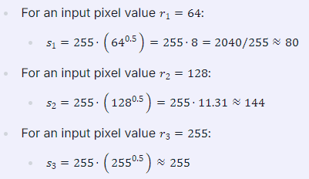

1. **Resulting Image**: After applying this transformation across all pixels in the image, we would observe that darker areas become significantly brighter while maintaining some detail in brighter areas.

In summary, Power Law transformations are effective tools for enhancing images by adjusting their brightness and contrast based on nonlinear mappings defined by gamma values.

**---------------------------------------------------------------------------------------------------------------------**

**Image Enhancement** refers to the process of improving the visual appearance of an image or making it more suitable for analysis by enhancing certain features, such as contrast, brightness, or edges. This process is widely used in various fields, including medical imaging, satellite imagery, and photography, to help bring out details that might be obscured or not clearly visible in the original image.

The goal of image enhancement is not necessarily to produce an image that looks more realistic, but rather one that is more interpretable or highlights specific features of interest.

### ****Power Law (Gamma) Transformation****

The **Power Law Transformation**, often referred to as **Gamma Correction**, is a type of image enhancement technique that applies a nonlinear transformation to each pixel in the image. This method is useful for correcting the brightness of images and can be used to make images appear more natural to the human eye.

The transformation function is defined as:



where:

* s is the output pixel value (transformed intensity).
* r is the input pixel value (original intensity).
* c is a constant that can be used to scale the output (often set to 1).
* γ (gamma) is the exponent in the transformation and controls the nature of the transformation.

### ****Types of Gamma Correction****

* **Gamma < 1**: This type of correction is used to brighten the image. It enhances the brightness of darker regions while reducing the brightness of lighter regions. This is often used in situations where the image appears too dark.
* **Gamma = 1**: This is the identity transformation where the output is identical to the input. No change occurs in the image.
* **Gamma > 1**: This type of correction is used to darken the image. It reduces the brightness of lighter regions and is useful when the image appears too bright.

### ****Example of Power Law Transformation****

Consider an 8-bit grayscale image where the pixel values range from 0 to 255.

#### **1. Brightening an Image (Gamma < 1)**

Let's say you apply a gamma correction with γ = 0.5:

* **Original pixel value**: If the input pixel value is r = 100,
* **Transformed pixel value**: The output pixel value would be s = 1000.5 = 10.

This process will be applied to all pixel values, making the overall image appear brighter, especially in darker areas.

#### **2. Darkening an Image (Gamma > 1)**

Now, consider a gamma correction with γ=2.0:

* **Original pixel value**: If the input pixel value is r = 100,
* **Transformed pixel value**: The output pixel value would be s = 1002.0 = 10000 (Since we are working in an 8-bit range, this value will be clipped to the maximum value, which is 255).

This would result in the darker regions becoming more prominent and the image appearing overall darker.

### ****Visualization****

Imagine a scenario where you have an underexposed image (too dark). If you apply a gamma correction with γ = 0.5, the image will become brighter, and details that were not previously visible due to darkness may now be visible.

On the other hand, if you have an overexposed image (too bright), applying a gamma correction with γ = 2.0 will darken the image, enhancing the details that were washed out due to excessive brightness.

### ****Applications****

* **Display Systems**: Gamma correction is crucial in adjusting images for different display systems like monitors, TVs, and projectors to ensure consistent brightness and contrast.
* **Photography**: Used to adjust the exposure and bring out details in different lighting conditions.
* **Medical Imaging**: Enhancing the visibility of features in medical scans (like X-rays) by adjusting the contrast.

### ****Conclusion****

Power Law (Gamma) Transformation is a fundamental technique in image enhancement, providing a way to correct and adjust the brightness of images to enhance their visual quality. The choice of gamma value allows for flexible control over the enhancement process, making it suitable for various applications.

**Define Digital image. Explain steps involves in digital image processing with diagram.**

A digital image is a representation of a two-dimensional image as a finite set of digital values, typically organized in a grid format. Each value corresponds to the brightness or color of a pixel in the image. Digital images can be classified into two main types: raster images and vector images. Raster images are composed of pixels arranged in a grid, while vector images are made up of paths defined by mathematical equations.

Digital images are stored in various formats such as JPEG, PNG, BMP, and TIFF, each with its own method of compression and quality characteristics. The fundamental aspect of digital images is that they can be manipulated using computer algorithms for various applications including photography, medical imaging, remote sensing, and more.

**Steps Involved in Digital Image Processing**

Digital image processing involves several steps that transform an input image into an output image through various operations. The following steps outline the typical workflow involved in digital image processing:

1. **Image Acquisition**
   * This is the first step where an image is captured using sensors or cameras. The acquired image can be in analog form (like photographs) or already in digital form (like those from digital cameras).
2. **Preprocessing**
   * In this step, the acquired image undergoes initial processing to enhance its quality and prepare it for further analysis. Common preprocessing techniques include noise reduction (removing unwanted variations), contrast enhancement (improving visibility), and geometric transformations (resizing or rotating).
3. **Segmentation**
   * Segmentation involves dividing the processed image into meaningful regions or segments for easier analysis. This could involve identifying objects within an image based on color, intensity, or texture.
4. **Feature Extraction**
   * After segmentation, relevant features are extracted from each segment to describe their properties quantitatively. Features may include shape descriptors, texture measures, and color histograms.
5. **Image Analysis**
   * This step involves analyzing the extracted features to make decisions or classifications about the content of the image. Techniques like pattern recognition and machine learning may be employed here.
6. **Post-processing**
   * Post-processing refers to any additional modifications made after analysis to improve visual quality or prepare data for presentation or storage.
7. **Image Display/Output**
   * Finally, the processed image is displayed on a screen or saved in a specific file format for future use.

**Diagram Representation**

Below is a simplified diagram representing these steps:

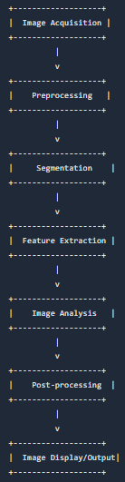

Each step plays a crucial role in ensuring that the final output meets the desired specifications for further use or analysis.

**---------------------------------------------------------------------------------------------------------------------**

A **Digital Image** is a representation of a two-dimensional image using a finite set of digital values, called pixels, in a grid. Each pixel represents a color or intensity level, and these values are typically stored in a binary format. The digital image can be acquired by sampling a continuous image in both spatial coordinates and intensity, which is then quantized to produce a matrix of numerical values.

* **Pixels**: The smallest unit of a digital image, representing the color or intensity of the image at a specific location.
* **Resolution**: The number of pixels per unit area, which determines the image's detail and clarity.
* **Bit Depth**: The number of bits used to represent the intensity of each pixel, affecting the range of colors or shades that can be displayed.

### ****Steps Involved in Digital Image Processing****

Digital Image Processing involves a series of steps that convert a raw digital image into a more useful form for analysis, visualization, or further processing. The typical steps are:

#### **1. Image Acquisition**

* **Description**: This is the first step in digital image processing, where the image is captured using a sensor, such as a camera, scanner, or satellite. The output is a digital image.
* **Purpose**: To convert the physical image into a digital form that can be processed by a computer.

#### **2. Image Preprocessing**

* **Description**: Preprocessing involves enhancing the image to make it more suitable for further processing. This step includes noise reduction, contrast enhancement, and image scaling.
* **Techniques**:
  + **Noise Removal**: Using filters to reduce random variations in intensity.
  + **Contrast Adjustment**: Enhancing the contrast to improve the visibility of details.
  + **Image Resizing**: Scaling the image to a desired size.

#### **3. Image Segmentation**

* **Description**: Segmentation divides the image into meaningful regions or objects. It simplifies the image by reducing it to a set of regions that can be analyzed individually.
* **Techniques**:
  + **Thresholding**: Converting the image into binary form based on intensity.
  + **Edge Detection**: Identifying boundaries of objects within the image.
  + **Region-Based Segmentation**: Grouping pixels into regions based on similarity.

#### **4. Image Representation and Description**

* **Description**: After segmentation, the image or its regions are represented in a way that is useful for analysis. This may involve extracting features such as shape, texture, or color.
* **Techniques**:
  + **Boundary Representation**: Describing the shape of regions.
  + **Texture Analysis**: Quantifying the texture of regions for classification.

#### **5. Image Enhancement**

* **Description**: Enhancement improves the quality of the image, making it more interpretable. This can involve adjusting brightness, contrast, or sharpness.
* **Techniques**:
  + **Histogram Equalization**: Adjusting contrast by modifying the histogram distribution.
  + **Sharpening**: Enhancing edges to make objects more distinguishable.
  + **Filtering**: Applying filters to emphasize or suppress specific features.

#### **6. Image Compression**

* **Description**: Compression reduces the amount of data required to store or transmit the image without significantly compromising quality.
* **Techniques**:
  + **Lossless Compression**: Reducing file size without losing any information (e.g., PNG).
  + **Lossy Compression**: Reducing file size by removing some data (e.g., JPEG).

#### **7. Image Restoration**

* **Description**: Restoration is the process of improving the appearance of an image by reversing known distortions, such as blur or noise.
* **Techniques**:
  + **De-blurring**: Reversing the effects of motion or defocus blur.
  + **Noise Reduction**: Removing unwanted noise while preserving important details.

#### **8. Image Analysis and Interpretation**

* **Description**: This step involves analyzing the processed image to extract meaningful information, such as object recognition, pattern recognition, or scene understanding.
* **Techniques**:
  + **Feature Extraction**: Identifying key features like edges, corners, or shapes.
  + **Classification**: Categorizing objects within the image based on extracted features.
  + **Pattern Recognition**: Identifying patterns or objects within the image.

### ****Diagram of Digital Image Processing Steps****

Here's a simplified diagram showing the typical flow of digital image processing:

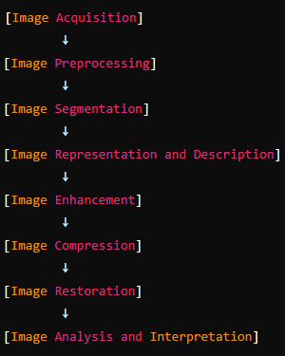

### ****Conclusion****

Digital image processing is a comprehensive field that involves several key steps, each playing a crucial role in converting a raw digital image into a form that can be effectively analyzed, interpreted, and utilized. These steps, from acquisition to analyzing and interpreting the results, enable various applications in fields such as medical imaging, satellite imagery, computer vision, and multimedia processing.

**Explain the term Contrast Stretching with example.**

**Contrast Stretching**

**Definition and Purpose**

Contrast stretching, also known as normalization, is an image enhancement technique used to improve the contrast of an image by expanding the range of intensity values it contains. The goal is to stretch the minimum and maximum pixel values present in the image to fill the entire dynamic range allowed by the image type, which is typically from 0 to 255 for 8-bit grayscale images. This process helps in making features within the image more distinguishable.

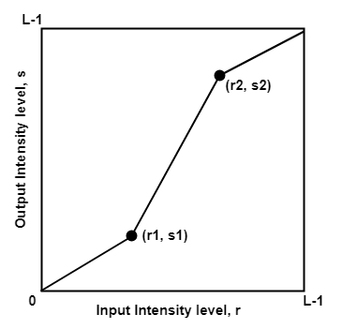

**How It Works**

The process begins by identifying the lowest (c) and highest (d) pixel intensity values currently present in the image. These values are then mapped to a new range defined by specified lower (a) and upper (b) limits. For example, if we have an 8-bit grayscale image where the minimum pixel value is 100 and the maximum pixel value is 200, we can apply contrast stretching to map these values to 0 and 255 respectively.

The formula used for contrast stretching can be expressed as:

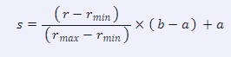

Where:

* s = output pixel value
* r = current pixel intensity value
* rmin = minimum intensity value present in the original image
* rmax = maximum intensity value present in the original image
* a = desired minimum output intensity (usually 0)
* b = desired maximum output intensity (usually 255)

**Example:**  
Consider an example where we have a grayscale image with pixel intensity values ranging from 100 to 200. To perform contrast stretching:

1. **Identify Minimum and Maximum Values:**
   * Minimum (rmin) = 100
   * Maximum (rmax) = 200
2. **Set Desired Output Range:**
   * Lower limit (a) = 0
   * Upper limit (b) = 255
3. **Apply Contrast Stretching Formula:** For each pixel value r:



If we take a specific pixel with an original value (r) of 150:

s = $\frac{\left(150 - 100\right) }{(200 - 100 )}$* (255 – 0) + 0

= 127.5 => 128 (Approx)

Thus, after applying contrast stretching, a pixel originally valued at 150 would be transformed to approximately 128.

This transformation effectively enhances the overall contrast of the image, making it easier to identify features that were previously less distinguishable due to low contrast.

**Conclusion**  
Contrast stretching is particularly useful when dealing with images that have low contrast due to limited dynamic range or poor lighting conditions. By redistributing pixel intensities across their full potential range, it significantly improves visual quality without distorting relative gray levels too much.

**---------------------------------------------------------------------------------------------------------------------**

**Contrast Stretching** is an image enhancement technique used to improve the contrast of an image by stretching the range of intensity values. The goal is to increase the dynamic range of the pixel intensities, making dark areas darker and bright areas brighter, thus enhancing the overall visibility of features in the image.

### ****How Contrast Stretching Works****

In many images, the pixel intensity values might be clustered within a narrow range, making the image appear dull or washed out. Contrast stretching redistributes these pixel intensities across a wider range, typically the full available range of the image's bit depth (e.g., 0 to 255 for an 8-bit image).

#### **Mathematical Explanation**

The transformation can be mathematically expressed as:



Where:

* s is the output pixel intensity.
* r is the input pixel intensity.
* rmin and rmax​ are the minimum and maximum intensity values in the input image.
* smin and smax​ are the desired minimum and maximum intensity values in the output image, often set to 0 and 255 for an 8-bit image.

### ****Steps in Contrast Stretching****

1. **Identify the Range**: Determine the minimum (rmin) and maximum (rmax​) intensity values in the original image.
2. **Apply the Transformation**: Use the formula to map the input pixel values to the new range, stretching the contrast across the desired range.
3. **Update Pixel Values**: Each pixel in the original image is transformed to its corresponding new value, creating an image with enhanced contrast.

### ****Example of Contrast Stretching****

Let's say you have an 8-bit grayscale image where the pixel values range from 50 to 150 (instead of the full 0 to 255 range).

* **Original Image Range**: 50 to 150
* **Desired Range**: 0 to 255

Using contrast stretching:

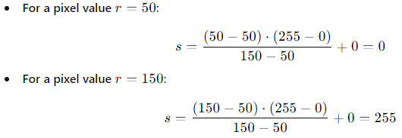

Thus, the entire intensity range of the original image (50 to 150) is stretched to the full range of 0 to 255, enhancing the contrast.

### ****Visualization of the Effect****

Before contrast stretching, an image might appear as follows:

* **Dark areas**: Intensity values are closer together, resulting in a flat, low-contrast look.
* **Bright areas**: Similarly, bright regions might not be fully white, appearing grayish.

After applying contrast stretching:

* **Dark areas**: Become darker, increasing the difference between shadows and highlights.
* **Bright areas**: Become brighter, making the image look more dynamic.

### ****Applications of Contrast Stretching****

* **Medical Imaging**: Enhancing the visibility of details in X-rays, MRI scans, and other medical images.
* **Satellite Imagery**: Improving contrast in satellite photos to better distinguish between land cover types.
* **Photography**: Enhancing the contrast of photographs, particularly when taken under low-light conditions.

### ****Conclusion****

Contrast stretching is a simple yet effective technique for enhancing the visual quality of an image by expanding the range of intensity values. It makes the details more pronounced and can significantly improve the interpretability of an image in various applications.

**What is a gradient filter? Explain the Sobel gradient filter in detail along with its algorithm for implementation.**

A **gradient filter** is an image processing tool used to detect edges within an image by calculating the gradient of the image intensity at each pixel. The gradient is a measure of how much and in which direction the intensity of the image changes. By applying a gradient filter, you can identify regions of rapid intensity change, which typically correspond to edges in the image.

### Sobel Gradient Filter

The **Sobel gradient filter** is one of the most widely used edge detection methods in image processing. It computes an approximation of the gradient of the image intensity function, and it is particularly effective at highlighting edges in both the horizontal and vertical directions. The Sobel filter is named after Irwin Sobel, who introduced it in the 1960s.

#### **Sobel Filter Basics**

The Sobel filter uses two 3x3 convolution kernels (filters), one for detecting horizontal edges and one for detecting vertical edges. The two kernels are designed to emphasize edges by calculating the difference between pixel values in the respective directions.

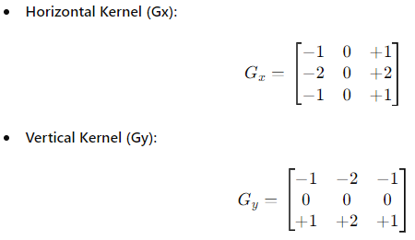

#### **How the Sobel Filter Works**

The Sobel filter works by sliding the Gx and Gy kernels over the image, computing the convolution between the kernel and the pixel values in the image. The convolution operation involves multiplying the corresponding elements of the kernel and the image pixel values, summing them up, and assigning the result to the center pixel.

For each pixel in the image:

* The horizontal gradient (Gx) is calculated by convolving the image with the horizontal kernel.
* The vertical gradient (Gy) is calculated by convolving the image with the vertical kernel.
* The magnitude of the gradient at each pixel is then computed using the formula:



* The direction of the gradient (edge direction) can be computed using the formula:



### ****Algorithm for Sobel Filter Implementation****

Here’s a step-by-step algorithm to implement the Sobel filter:

1. **Convert the Image to Grayscale (if needed):**

* If the input image is in color, convert it to a grayscale image, as edge detection is typically performed on a single channel.

2. **Apply the Sobel Kernels:**

* Perform convolution of the image with the Gx kernel to calculate the horizontal gradient at each pixel.
* Perform convolution of the image with the Gy kernel to calculate the vertical gradient at each pixel.

**3. Calculate the Gradient Magnitude:**

* For each pixel, compute the gradient magnitude



**4. Calculate the Gradient Direction (Optional):**

* For each pixel, compute the gradient direction



**5.** **Thresholding (Optional):**

* Apply a threshold to the gradient magnitude to produce a binary edge map, where pixels with gradient magnitudes above the threshold are considered edges.

**6.** **Output the Result:**

* The output can be the gradient magnitude image, which highlights edges in the image, or a binary edge map if thresholding is applied.

### ****Example of Sobel Filter in Action****

Consider a small 5x5 image with pixel intensity values:

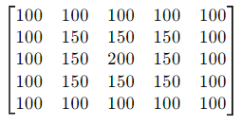

To apply the Sobel filter:

* **Horizontal Gradient (Gx):** Convolve the image with the Gx kernel.
* **Vertical Gradient (Gy):** Convolve the image with the Gy kernel.
* **Gradient Magnitude (G):** Calculate the magnitude for each pixel using:



The resulting gradient magnitude image will emphasize the edges in both the horizontal and vertical directions, where the pixel intensity changes rapidly.

### ****Applications of Sobel Filter****

* **Edge Detection**: Identifying object boundaries within an image.
* **Feature Extraction**: Preprocessing step in object detection and recognition tasks.
* **Image Sharpening**: Enhancing the edges of objects within an image.

### ****Conclusion****

The Sobel gradient filter is a powerful tool for edge detection in digital images. By calculating the gradient magnitude and direction, it effectively identifies edges, which are crucial for tasks like object recognition, segmentation, and image analysis. The simplicity and effectiveness of the Sobel filter make it a popular choice in various image processing applications.

**What's histogram equalization?**

**Histogram equalization** is a technique in image processing used to improve the contrast of an image by redistributing the intensity values. The goal is to produce an image with a more uniform histogram, meaning the intensity values are spread out across the entire range, thereby enhancing the overall visibility of features in the image.

### How Histogram Equalization Works

To understand histogram equalization, let's first briefly look at what a histogram is in the context of an image:

* **Image Histogram:** An image histogram is a graphical representation of the distribution of pixel intensity values in an image. For a grayscale image, the histogram shows the frequency of each intensity level (ranging from 0 to 255 for an 8-bit image).

In many images, the pixel intensities may cluster in a narrow range, which results in poor contrast. For example, if most of the pixels have intensity values between 50 and 100, the image might look washed out or too dark.

Histogram equalization addresses this by spreading out the most frequent intensity values, thereby improving the global contrast of the image.

#### **Steps Involved in Histogram Equalization**

1. **Calculate the Histogram:**
   * Compute the histogram of the image, which gives the frequency of each intensity level.
2. **Compute the Cumulative Distribution Function (CDF):**
   * The CDF is calculated by accumulating the histogram values. The CDF gives the cumulative probability of each intensity level.
3. **Normalize the CDF:**
   * Normalize the CDF so that its values range from 0 to 255 (for an 8-bit image). This is done by mapping the intensity levels using the formula:



Where:

* + sk​ is the new intensity value.
  + rk is the original intensity value.
  + CDF(rk) is the CDF of rk​.
  + CDFmin​ is the minimum non-zero value of the CDF.
  + L is the number of possible intensity levels (256 for an 8-bit image).

1. **Map the Original Intensities to the Equalized Values:**
   * Replace each pixel intensity in the original image with its corresponding equalized value obtained from the normalized CDF.
2. **Resulting Image:**
   * The output is a contrast-enhanced image where the intensity levels are more uniformly distributed across the available range.

### Example of Histogram Equalization

Consider a grayscale image where most pixels have intensity values between 60 and 120. The histogram of such an image would show a peak in this range and low values elsewhere.

* **Before Histogram Equalization:**
  + The image might appear dull or with low contrast because most pixel values are confined to a small part of the available intensity range.
* **After Histogram Equalization:**
  + The histogram is stretched across the full intensity range (0 to 255), and the image has improved contrast. Features that were previously hard to see become more visible.

### Applications of Histogram Equalization

* **Medical Imaging:** Enhances the visibility of structures in X-ray, MRI, and CT images.
* **Satellite Imaging:** Improves the contrast of satellite images to make land features more distinguishable.
* **Photography:** Used in post-processing to enhance the contrast of photos.
* **Computer Vision:** Preprocessing step for object detection and recognition tasks.

### Conclusion

Histogram equalization is a powerful and widely-used technique in image processing that enhances the contrast of an image by redistributing the intensity values. It is particularly effective in making details in low-contrast images more visible, thus improving the visual quality and making the image more suitable for analysis.

**Compute the histogram equalization of the given data.**

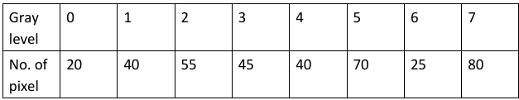

Let's perform histogram equalization on the given data step by step.

Given Data:

* **Gray levels:** 0, 1, 2, 3, 4, 5, 6, 7
* **Number of pixels:** 20, 40, 55, 45, 40, 70, 25, 80

**Step 1: Compute the Probability Density Function (PDF)**

The Probability Density Function (PDF) is the probability of each gray level occurring in the image. It is calculated by dividing the number of pixels at each gray level by the total number of pixels.

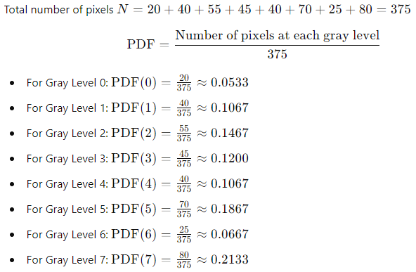

**Step 2: Compute the Cumulative Distribution Function (CDF)**

The Cumulative Distribution Function (CDF) is the cumulative sum of the PDF values.

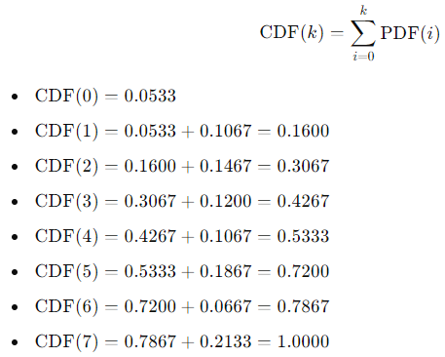

**Step 3: Compute the New Intensity Values**

The new intensity value for each gray level is calculated by multiplying the CDF by the maximum gray level (in this case, 7) and rounding to the nearest integer.

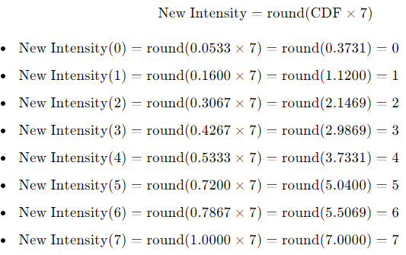

**Step 4: Mapping the Old Intensities to New Intensities**

Finally, we map each original gray level to its corresponding new intensity value:

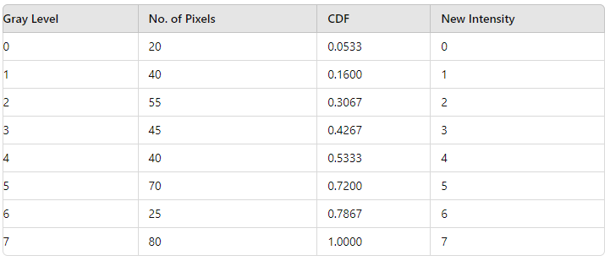

**Result:**

The histogram equalization process has mapped the original gray levels to new intensities, with the intensity levels more evenly distributed across the range. This results in an image with enhanced contrast.

**Explain why Fast Fourier Transform (FFT) is better than Discrete Fourier Transform (DFT) with example.**

**Introduction to Fourier Transforms**

The Fourier Transform is a mathematical technique used to transform signals between time (or spatial) domain and frequency domain. The Discrete Fourier Transform (DFT) and its efficient algorithm, the Fast Fourier Transform (FFT), are widely used in signal processing, image analysis, and many other fields. Understanding why FFT is considered superior to DFT involves examining their computational efficiency, implementation complexity, and practical applications.

**Discrete Fourier Transform (DFT)**

The DFT converts a finite sequence of equally spaced samples of a function into a same-length sequence of coefficients of complex exponentials. Mathematically, for a sequence x[n] of length N, the DFT is defined as:

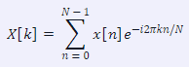

for k=0,1,...,N−1. The computational complexity of calculating the DFT directly using this formula is *O(N2),* which means that if you double the number of input points, the computation time increases by a factor of four.

**Fast Fourier Transform (FFT)**

The FFT is an algorithm designed to compute the DFT efficiently. The most common FFT algorithm is the Cooley-Tukey algorithm, which reduces the computational complexity from *O(N2)* to *O(N log N)*. This significant reduction in complexity allows for much faster computations, especially for large datasets.

**Comparison: Efficiency**

To illustrate why FFT is better than DFT, consider an example where we need to compute the DFT of a signal with 1024 samples:

1. **Using DFT**:
   * Computational Complexity: O(N2) = O(10242) = 1,048,576
   * This means approximately over one million operations are required.
2. **Using FFT**:
   * Computational Complexity: *O(N log N)* = O(1024*log2(1024)) = O(1024*10) = 10,240
   * This results in just over ten thousand operations.

From this comparison, it’s clear that using FFT drastically reduces the number of calculations needed to perform the transformation.

**Implementation Complexity**

In addition to computational efficiency, implementing FFT algorithms can be simpler due to their recursive nature and ability to handle data in smaller chunks. The structure of FFT allows for optimizations such as reusing previously computed values and reducing memory access times compared to direct implementations of DFT.

**Practical Applications**

In real-world applications such as audio signal processing or image compression (like JPEG), where large datasets are common, using FFT becomes essential due to its speed. For instance:

* In audio processing: An application may require real-time analysis of sound waves; using FFT allows for quick transformations necessary for tasks like equalization or filtering.
* In image processing: Techniques like convolution often rely on frequency domain transformations; using FFT enables faster processing times when manipulating images.

**Conclusion**

In summary, while both DFT and FFT serve similar purposes in transforming signals between domains, the Fast Fourier Transform offers substantial advantages in terms of computational efficiency and practical applicability. The reduction from *O(N2)* operations with DFT to *O(N log N)* with FFT makes it indispensable in modern computing environments where speed and efficiency are critical.

**Bold Answer:** **The Fast Fourier Transform (FFT) is better than Discrete Fourier Transform (DFT) primarily due to its significantly lower computational complexity (O(N log N) vs. O(N2)), making it much faster for large datasets while also simplifying implementation through recursive techniques.**

---------------------------------------------------------------------------------------------------------------------

### Fast Fourier Transform (FFT) vs. Discrete Fourier Transform (DFT)

The **Discrete Fourier Transform (DFT)** is a mathematical technique used to convert a sequence of time-domain signals into a frequency-domain representation. While DFT is highly useful in signal processing, it has a significant computational complexity, making it impractical for large datasets. The **Fast Fourier Transform (FFT)** is an algorithm that efficiently computes the DFT, significantly reducing the computational time and resources required.

#### **1. Discrete Fourier Transform (DFT)**

The DFT of a sequence x[n] of length N is defined as:

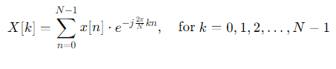

Where:

* x[n] is the input sequence.
* X[k] is the DFT output for each frequency k.
* N is the total number of points in the input sequence.
* e−j2πkn/N is the complex exponential function.

#### **2. Computational Complexity of DFT**

The DFT requires N2 complex multiplications and N(N−1) complex additions, where N is the number of points in the input sequence. This quadratic complexity means that as N increases, the computational cost grows rapidly, making the DFT computationally expensive for large datasets.

#### **3. Fast Fourier Transform (FFT)**

The FFT is an optimized algorithm to compute the DFT. The most commonly used FFT algorithm is the Cooley-Tukey algorithm, which divides the DFT computation into smaller parts and then combines the results. The FFT reduces the computational complexity from *O(N2)* to *O(N log N),* making it much faster and more efficient.

#### **4. Why FFT is Better than DFT**

* **Computational Efficiency:**
  + **DFT:** Requires *O(N2)* operations.
  + **FFT:** Requires *O(N log N)* operations. For large N, this is a substantial improvement, reducing the computation time by orders of magnitude.
* **Practicality for Large Data Sets:**
  + The FFT's reduced complexity makes it feasible to process large datasets in real-time, which would be impractical with the DFT due to the excessive computation time.
* **Real-time Applications:**
  + FFT is essential in applications that require real-time signal processing, such as audio and video compression, radar and sonar systems, and communications. The speed of the FFT allows for real-time analysis of signals, which is critical in these applications.

#### **5. Example**

Consider a signal processing example where you have a dataset of N = 1024 points.

* **Using DFT:** The computational complexity is *O(N2)* = 10242 = 1,048,576 operations.
* **Using FFT:** The computational complexity is *O(N log N)* = 1024 ×log21024 = 1024×10 = 10,240 operations.

As seen from the example, the FFT requires significantly fewer operations than the DFT. This difference becomes even more pronounced as N increases.

#### **6. Conclusion**

The FFT is better than the DFT in terms of computational efficiency, especially for large datasets. While both transform the time-domain signal into the frequency domain, the FFT's reduced complexity allows it to be used in real-time applications and large-scale problems where the DFT would be computationally prohibitive. The FFT has become a cornerstone of modern digital signal processing, enabling efficient analysis and manipulation of signals across a wide range of applications.

**How dilation and erosion are applied in region filling and boundary extraction.**

**Dilation and Erosion in Region Filling and Boundary Extraction**

**Introduction to Dilation and Erosion**

Dilation and erosion are fundamental operations in mathematical morphology, a branch of image processing that focuses on the shape or structure of objects within an image. These operations are particularly useful for tasks such as region filling and boundary extraction, which are essential in various applications including computer vision, medical imaging, and object recognition.

**Dilation**

Dilation is an operation that adds pixels to the boundaries of objects in an image. It works by placing a structuring element (a predefined shape) over each pixel in the binary image. If any pixel under the structuring element is part of the foreground (typically represented by a value of 1), the pixel at the center of the structuring element is set to 1. This effectively enlarges the size of foreground objects.

In region filling, dilation can be used to fill small holes or gaps within an object. By repeatedly applying dilation, one can progressively fill these gaps until they disappear entirely. This is particularly useful when dealing with noisy images where small imperfections may disrupt analysis.

**Erosion**

Erosion, on the other hand, removes pixels from the boundaries of objects. It also uses a structuring element but operates inversely compared to dilation. For erosion to occur at a pixel location, all pixels under the structuring element must be part of the foreground; otherwise, that pixel will be set to 0 (background).

In boundary extraction, erosion can help isolate object boundaries by shrinking them inward. When applied after dilation (in a process known as opening), it can effectively remove noise while preserving significant structures in an image.

**Application in Region Filling**

In region filling tasks, dilation is often employed first to expand regions that need filling. The process typically involves:

1. **Initial Dilation:** Start with a binary image where regions of interest are marked as foreground (1). Apply dilation using an appropriate structuring element.
2. **Iterative Dilation:** Repeat this process until all small holes within larger regions are filled.
3. **Post-Processing:** Optionally apply erosion afterward to refine edges if necessary.

This method ensures that even small gaps within larger connected components are filled without significantly altering their overall shape.

**Application in Boundary Extraction**

For boundary extraction, erosion plays a critical role:

1. **Initial Erosion:** Begin with a binary image containing distinct shapes or objects. Apply erosion using a suitable structuring element.
2. **Boundary Detection:** The result highlights only those pixels that form part of the boundaries since non-boundary pixels will be removed.
3. **Further Processing:** Dilation can then be applied after erosion if needed to enhance visibility or connectivity of detected boundaries.

This sequence allows for clear identification of object outlines while minimizing interference from noise or irrelevant details.

**Conclusion**

Both dilation and erosion serve crucial roles in image processing tasks such as region filling and boundary extraction by manipulating pixel arrangements based on structural elements. Their combined use allows for effective enhancement and analysis of images across various applications.

**---------------------------------------------------------------------------------------------------------------------**

### Dilation and Erosion in Region Filling and Boundary Extraction

Dilation and erosion are fundamental operations in morphological image processing. They are widely used in tasks like region filling and boundary extraction. These operations manipulate the shapes in a binary image based on a structuring element, typically a small matrix.

### 1. ****Dilation and Erosion: Basic Concepts****

* **Dilation:**
  + Dilation adds pixels to the boundaries of objects in an image. The amount and location of the pixels added are determined by the structuring element.
  + It is typically used to grow or expand the shapes in a binary image.
* **Erosion:**
  + Erosion removes pixels from the boundaries of objects in an image. Like dilation, the structuring element determines which pixels are removed.
  + It is typically used to shrink or reduce the shapes in a binary image.

### 2. ****Region Filling Using Dilation and Erosion****

Region filling is the process of filling in the holes or gaps within a region in a binary image. A "hole" is defined as a background region surrounded by a connected border of foreground pixels.

#### **Algorithm for Region Filling:**

1. **Initialize:**
   * Start with an initial point inside the hole to be filled, denoted as X0​.
   * The complement of the original image is denoted as I′, and a structuring element (e.g., a 3x3 square) is denoted as B.
2. **Iteration:**
   * Apply the following iterative formula to fill the region:



Where ⊕ represents the dilation operation and ∩ represents the intersection with the complement of the original image.

1. **Termination:**
   * The process is repeated until Xk+1​ equals Xk​, meaning no further changes occur.
2. **Final Image:**
   * The filled region is obtained by combining the original image with the filled region Xk.

#### **Example:**

Imagine a binary image with a simple shape containing a small hole. By starting from a pixel inside the hole, the dilation operation progressively fills the hole until it is completely filled, resulting in a solid shape.

### 3. ****Boundary Extraction Using Erosion****

Boundary extraction involves identifying the boundary or outline of objects in a binary image. This is done by subtracting an eroded version of the object from the original image.

#### **Algorithm for Boundary Extraction:**

1. **Erosion:**
   * Erode the original image III using a structuring element B, resulting in *I ⊖ B*, where ⊖ denotes the erosion operation.
2. **Subtract:**
   * Subtract the eroded image from the original image to extract the boundary:

*Boundary = I - (I ⊖ B)*

1. **Result:**
   * The result is a binary image showing only the boundary pixels of the original objects.

#### **Example:**

Consider a binary image with a shape like a circle. By applying erosion, the shape shrinks slightly. Subtracting the eroded image from the original leaves only the outermost layer of pixels, effectively highlighting the boundary.

### 4. ****Applications of Region Filling and Boundary Extraction****

* **Region Filling:**
  + Used in image editing to fill unwanted gaps or holes.
  + Helps in medical imaging to fill voids in segmented structures like organs.
* **Boundary Extraction:**
  + Important in object detection and recognition tasks, where identifying the boundary is crucial.
  + Used in contour detection in computer vision applications.

### 5. ****Conclusion****

Dilation and erosion are powerful tools in morphological image processing, particularly for region filling and boundary extraction. By using these operations, it is possible to manipulate binary images in ways that allow for the filling of regions and precise boundary detection. These techniques are essential in various applications, from medical imaging to computer vision and beyond.

**Explain Global, local, and Adaptive thresholding in segmentation**

**Global Thresholding**

Global thresholding is a straightforward segmentation technique where a single threshold value is applied uniformly across the entire image. This method works effectively when the intensity distribution of the foreground and background is distinct, allowing for clear separation. The basic steps involved in global thresholding include:

1. **Select an Initial Threshold**: An initial estimate of the threshold (T) is chosen, often based on the average pixel intensity of the image.
2. **Segment the Image**: The image is segmented into two groups based on this threshold: pixels with intensity values greater than T are classified as foreground (white), while those less than or equal to T are classified as background (black).
3. **Iterate to Optimize**: The algorithm iteratively computes new average intensities for both groups and updates the threshold until convergence, meaning that subsequent iterations yield minimal changes in T.

This method is particularly effective for images with a bimodal histogram where two distinct peaks represent different objects or regions.

**Local Thresholding**

Local thresholding addresses some limitations of global thresholding by applying different thresholds to smaller regions within an image rather than using a single global value. This approach is beneficial for images with varying lighting conditions or complex backgrounds where illumination may not be uniform across the entire image. The process typically involves:

1. **Partitioning the Image**: The image is divided into smaller overlapping or non-overlapping sub-regions.
2. **Calculating Local Thresholds**: A threshold value is computed for each sub-region based on local pixel properties, such as mean or median intensity.
3. **Segmentation**: Each pixel in these sub-regions is then classified according to its respective local threshold.

Local thresholding allows for better adaptability to variations in illumination and can lead to more accurate segmentation results in challenging imaging scenarios.

**Adaptive Thresholding**

Adaptive thresholding takes local thresholding a step further by dynamically adjusting the threshold at each pixel based on its neighborhood characteristics. This method is particularly useful in situations where there are significant variations in lighting conditions across different areas of an image. The key steps include:

1. **Neighborhood Analysis**: For each pixel, statistical measures (like mean or standard deviation) are calculated from its surrounding pixels.
2. **Dynamic Threshold Calculation**: A unique threshold value for each pixel can be derived from these statistics, often incorporating constants that adjust sensitivity.
3. **Pixel Classification**: Each pixel’s intensity is compared against its calculated adaptive threshold; if it exceeds this value, it’s classified as foreground; otherwise, it’s considered background.

Adaptive thresholding techniques can handle complex images more effectively than both global and simple local methods since they account for localized variations in brightness and contrast.

In summary, while global thresholding applies a single fixed value across an entire image, local and adaptive methods provide flexibility by calculating thresholds based on localized pixel information, making them suitable for more complex imaging scenarios.

---------------------------------------------------------------------------------------------------------------------

Thresholding is a fundamental technique in image segmentation, used to separate objects (foreground) from the background in grayscale images by converting them into binary images. The method relies on selecting a threshold value, which determines whether a pixel belongs to the object or the background. There are three main types of thresholding techniques: Global, Local, and Adaptive.

### 1. Global Thresholding

**Global thresholding** uses a single threshold value for the entire image to segment the objects from the background.

#### How it works:

* A global threshold T is chosen.
* Every pixel in the image is compared to this threshold.
  + If the pixel intensity is greater than T, it is classified as part of the foreground (object) and assigned a value of 1.
  + If the pixel intensity is less than or equal to T, it is classified as part of the background and assigned a value of 0.

#### Example:

Consider an image with a bimodal histogram (two distinct peaks representing the object and the background). A suitable threshold value T is chosen, often using methods like Otsu's method, to separate the two peaks.

#### Advantages:

* Simple and fast.
* Effective for images where the intensity distribution between object and background is distinct and uniform.

#### Disadvantages:

* Fails when there is significant lighting variation or the object and background intensities overlap.

### 2. Local (or Regional) Thresholding

**Local thresholding** divides the image into smaller regions and applies different thresholds to each region based on its intensity characteristics.

#### How it works:

* The image is divided into sub-regions or blocks.
* A threshold is computed individually for each region.
* Each pixel is then compared to the threshold specific to its region.
  + Similar to global thresholding, if a pixel's intensity is above the threshold for its region, it is considered foreground; otherwise, it is background.

#### Example:

In an image with uneven illumination, the intensity of the background might vary across different regions. Local thresholding would handle this by setting different thresholds for different regions, leading to better segmentation results.

#### Advantages:

* More robust to varying illumination conditions across the image.
* Provides better results for images where global thresholding fails due to non-uniform lighting.

#### Disadvantages:

* More computationally intensive than global thresholding.
* The choice of region size is crucial; too small regions might lead to noise, while too large regions might not handle lighting variations well.

### 3. Adaptive Thresholding

**Adaptive thresholding** is a more refined version of local thresholding. Instead of dividing the image into regions, it calculates the threshold for each pixel based on its neighborhood.

#### How it works:

* For each pixel, a threshold is computed by analyzing the local neighborhood around the pixel.
* The threshold is often calculated as the mean or median intensity value of the neighborhood, sometimes adjusted by a constant C.
* The pixel is then classified as foreground or background based on this locally computed threshold.

#### Example:

In a document image with text on a non-uniform background, adaptive thresholding can effectively segment the text from the background by adjusting to local intensity variations.

#### Advantages:

* Highly effective for images with complex lighting conditions and varying intensity across the image.
* Can handle finer details and variations better than local thresholding.

#### Disadvantages:

* Computationally more expensive than global and local thresholding.
* The choice of neighborhood size and the constant C can affect the results.

### Summary

* **Global Thresholding**: Uses a single threshold for the entire image. Simple but ineffective in non-uniform lighting conditions.
* **Local Thresholding**: Uses different thresholds for different regions. Better for images with varying illumination but computationally more complex.
* **Adaptive Thresholding**: Computes thresholds for each pixel based on local neighborhoods. Highly effective in complex scenarios but the most computationally intensive.

Each method has its strengths and is chosen based on the specific characteristics of the image and the segmentation task at hand.

**Explain opening and closing morphological operations in brief.**

**Opening and Closing Morphological Operations**

**Overview of Morphological Operations** Morphological operations are techniques in digital image processing that analyze the shapes and structures within images. They are particularly useful for binary images, where pixels are either foreground (object) or background.

**Opening Operation** Opening is a morphological operation that consists of two steps: erosion followed by dilation. The primary purpose of opening is to remove small objects or noise from an image while preserving the shape and size of larger objects.

1. **Erosion**: In this step, the structuring element (a predefined shape) slides over the image, and a pixel in the output image is set to 1 (foreground) only if all pixels under the structuring element are also 1 in the input image. This effectively shrinks the boundaries of foreground objects.
2. **Dilation**: After erosion, dilation is applied using the same structuring element. This step expands the remaining foreground pixels back to their original size, but since smaller objects have been removed during erosion, they do not reappear.

The result of opening is that it cleans up small noise while keeping larger structures intact.

**Closing Operation** Closing is another morphological operation that consists of dilation followed by erosion. The main goal of closing is to fill small holes and gaps within foreground objects.

1. **Dilation**: In this initial step, dilation adds pixels to the boundaries of foreground objects based on the structuring element. This helps merge nearby objects and fills small holes.
2. **Erosion**: Following dilation, erosion is performed with the same structuring element to shrink back any expanded areas while maintaining the overall shape of larger objects.

The result of closing effectively smooths contours and connects disjoint parts of an object while eliminating small holes.

In summary, **opening** removes small noise from images without altering larger structures, while **closing** fills small holes and gaps in foreground objects.

**---------------------------------------------------------------------------------------------------------------------**

**Opening** and **Closing** are fundamental morphological operations used in image processing, particularly for binary images. These operations are based on the basic operations of **erosion** and **dilation** and are primarily used for noise removal, shape smoothing, and object separation or joining.

### 1. Opening

**Opening** is an operation that smooths the contour of an object, breaks narrow isthmuses, and eliminates small, isolated objects.

#### How it Works:

* **Step 1: Erosion**: First, the image undergoes erosion, which shrinks the objects in the image by removing pixels from their boundaries.
* **Step 2: Dilation**: The eroded image then undergoes dilation, which expands the objects again, but only in areas where the erosion left pixels.

#### Mathematical Representation:

***A∘ B = (A ⊖ B) ⊕ B***

Where:

* A is the input image.
* B is the structuring element.
* ⊖ represents erosion.
* ⊕ represents dilation.
* ∘ denotes the opening operation.

#### Purpose:

* **Noise Removal**: Opening removes small noise in the image while preserving the shape and size of larger objects.
* **Shape Smoothing**: It smooths the boundaries of objects by removing small protrusions.

#### Example:

If an image contains small noise elements or thin connections between objects, opening can remove the noise and break the connections, leaving the primary objects intact.

### 2. Closing

**Closing** is the dual operation of opening. It smooths the contour of objects, fills narrow gaps, and bridges small breaks.

#### How it Works:

* **Step 1: Dilation**: The image first undergoes dilation, which expands the objects by adding pixels to their boundaries.
* **Step 2: Erosion**: The dilated image then undergoes erosion, which shrinks the objects slightly, but not to the original extent before dilation.

#### Mathematical Representation:

***A∙B = (A ⊕ B) ⊖ B***

Where:

* A is the input image.
* B is the structuring element.
* ⊖ represents erosion.
* ⊕ represents dilation.
* **∙** denotes the closing operation.

#### Purpose:

* **Gap Filling**: Closing can fill small holes or gaps within objects.
* **Object Merging**: It can join together adjacent objects or close small breaks in their boundaries.

#### Example:

If an image contains small gaps or holes within objects, closing can fill these imperfections, creating more solid, continuous objects.

### Summary

* **Opening**: Erosion followed by dilation. Used for removing small objects or noise and disconnecting objects that are close to each other.
* **Closing**: Dilation followed by erosion. Used for closing small holes or gaps in objects and connecting objects that are close to each other.

Both operations are vital for preprocessing images to improve the quality of object detection, shape analysis, and segmentation tasks.

**Define digital image. How do you represent a digital image in computer?**

**Definition of Digital Image**

A **digital image** is defined as a two-dimensional function, F(x,y), where x and y are spatial coordinates. The amplitude of F at any pair of coordinates (x,y) is referred to as the intensity of that image at that point. When the values of x, y, and amplitude are finite, it is termed a digital image. Essentially, a digital image can be understood as being composed of a finite number of elements known as picture elements or pixels. Each pixel has a specific value corresponding to its location in the image.

**Representation of a Digital Image in Computer**

To represent a digital image in a computer, the following steps are typically involved:

1. **Image Acquisition**: This involves capturing an image using devices such as digital cameras or scanners. The acquired image is then converted into a format that can be processed by computers.
2. **Matrix Representation**: A digital image is represented as a two-dimensional array or matrix consisting of rows and columns. Each element in this matrix corresponds to a pixel in the image. For example, if an image has dimensions 100x100 pixels, it will be represented by a matrix with 100 rows and 100 columns.
3. **Pixel Values**: Each pixel in the matrix holds quantized values that represent brightness or color information at that specific point. For grayscale images, these values range from 0 (black) to 255 (white), while color images may use multiple channels (such as RGB) to represent different colors.
4. **Storage Formats**: The pixel data can be stored in various file formats such as JPEG, PNG, BMP, etc., which may also involve compression techniques to reduce file size while maintaining quality.
5. **Data Interpretation**: The binary data representing the pixel values is interpreted by software applications for display or further processing tasks.

In summary, a digital image is represented in computers through structured matrices containing pixel values that encode visual information about the original scene captured.

**---------------------------------------------------------------------------------------------------------------------**

A **digital image** is a representation of a two-dimensional image using a grid of pixels (picture elements) where each pixel has a specific value representing its intensity or color. Digital images are used extensively in computers, digital cameras, and other electronic devices to store and process visual information.

### Representation of a Digital Image in a Computer

Digital images are represented in a computer using various formats and structures. The key components and methods of representing a digital image include:

1. **Pixel Grid:**
   * A digital image is divided into a grid of pixels, each pixel representing the smallest unit of the image.
   * The resolution of an image is defined by the number of pixels along the width and height. For example, a 1920x1080 image has 1920 pixels horizontally and 1080 pixels vertically.
2. **Color Models:**
   * **Grayscale:** Each pixel is represented by a single value indicating its intensity. The range of values usually goes from 0 (black) to 255 (white) in 8-bit grayscale images.
   * **RGB (Red, Green, Blue):** Each pixel is represented by three values corresponding to the red, green, and blue color channels. Each channel value typically ranges from 0 to 255 in 8-bit images, allowing for 16.7 million possible colors.
   * **Other Color Models:** Other models such as CMYK (Cyan, Magenta, Yellow, Black) or HSV (Hue, Saturation, Value) may also be used depending on the application.
3. **Image Formats:**
   * **Bitmap (BMP):** A simple image format that represents images using a grid of pixels, where each pixel's color is stored as a specific value.
   * **JPEG (Joint Photographic Experts Group):** A compressed image format that uses lossy compression to reduce file size, suitable for photographic images.
   * **PNG (Portable Network Graphics):** A format that supports lossless compression and transparency, ideal for images with sharp edges and text.
   * **GIF (Graphics Interchange Format):** A format that supports simple animations and lossless compression, but with a limited color palette (256 colors).
4. **Image Data Structure:**
   * **Array Representation:** In a computer's memory, a digital image is typically stored as a multi-dimensional array (or matrix). For example, an RGB image of size 1920x1080 would be represented as a 3D array with dimensions 1920x1080x3.
   * **Bitmap Matrix:** In bitmap images, the matrix contains pixel values where each entry represents the intensity or color of the pixel.
5. **Metadata:**
   * Digital images may also contain metadata, which includes information about the image, such as resolution, color profile, creation date, and more. Metadata is stored separately from the pixel data but is crucial for proper interpretation and processing of the image.

### Example of Digital Image Representation

**Grayscale Image:** Consider a 4x4 grayscale image:

* Pixel values:

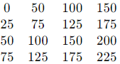

Each value represents the intensity of the pixel, with 0 being black and 255 being white.

**RGB Image:** Consider a 2x2 RGB image:

* Pixel values



Here, each pixel is represented by three values corresponding to the red, green, and blue color channels.

In summary, a digital image is represented in a computer as a grid of pixels, where each pixel holds information about intensity or color, depending on the image type and color model used. The image data is stored in arrays and can be saved in various formats, each suitable for different types of images and applications.

**What do you mean by image enhancement? Explain the operation of negative transformation with example.**

**Image Enhancement**

Image enhancement refers to the process of improving the visual quality of an image by modifying its characteristics. The goal is to make certain features more prominent or to improve the overall appearance of the image for better interpretation or analysis. This can involve various techniques, including contrast adjustment, noise reduction, sharpening, and color correction. Image enhancement is widely used in fields such as photography, medical imaging, remote sensing, and computer vision.

**Negative Transformation**

One specific technique within image enhancement is negative transformation. Negative transformation is a simple yet effective method that involves inverting the pixel values of an image. This operation can be particularly useful for highlighting certain features that may not be easily visible in the original image.

### Operation of Negative Transformation

1. **Understanding Pixel Values**: In digital images, each pixel has a value that represents its intensity or color. For grayscale images, this value typically ranges from 0 (black) to 255 (white). For color images, pixel values are represented in terms of three channels: Red, Green, and Blue (RGB), with each channel also ranging from 0 to 255.
2. **Inversion Process**: The negative transformation can be mathematically defined as follows:
   * For a grayscale image:

*I′(x, y) = L−1−I(x, y)*

where I(x, y) is the original pixel value at coordinates (x, y), L is the maximum possible pixel value (for an 8-bit image, L=256), and I′(x, y) is the new pixel value after transformation.

* + For a color image: Each channel’s pixel value is inverted separately using:
    - R′ = 255−R
    - G′ = 255−G
    - B′ = 255−B

where R, G, and B are the original red, green, and blue channel values respectively.

1. **Example**: Consider a simple grayscale image with pixel values as follows:

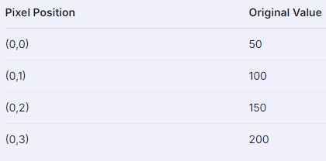

1. Applying negative transformation:

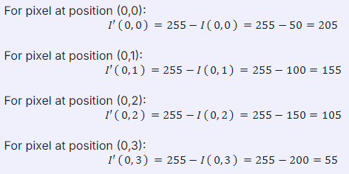

The transformed image will have the following pixel values:

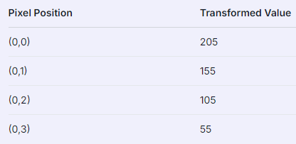

1. **Applications**: Negative transformations are often used in various applications such as enhancing features in medical images like X-rays or MRIs where certain structures may become more visible against a contrasting background.

**In summary:**

* Image enhancement improves visual quality.
* Negative transformation inverts pixel values.
* It highlights features by changing how they are perceived.

---------------------------------------------------------------------------------------------------------------------

**Image enhancement** refers to the process of improving the visual appearance or interpretability of an image. The goal is to make the image more suitable for a specific task, such as human viewing or further image analysis. Enhancement techniques can range from simple brightness and contrast adjustments to more complex operations like filtering and transformation.

Some common image enhancement techniques include:

* **Contrast adjustment**: Enhancing the difference between the light and dark areas of an image.
* **Histogram equalization**: Redistributing the intensities to improve the contrast.
* **Noise reduction**: Removing unwanted noise from the image.
* **Edge enhancement**: Highlighting the edges within an image to make the structure more defined.

### Negative Transformation

**Negative transformation** is a simple image enhancement technique where each pixel in the input image is transformed to its negative, effectively inverting the intensity values. This operation is particularly useful in applications where it is necessary to enhance white or bright details embedded in a dark background.

#### Operation of Negative Transformation

The negative transformation for a grayscale image is mathematically defined as:

*s = L−1−r*

Where:

* s is the output pixel value.
* r is the input pixel value.
* L is the number of possible intensity levels (typically 256 for an 8-bit image, where pixel values range from 0 to 255).

In simple terms, each pixel's value is subtracted from the maximum possible value (255 for an 8-bit image), resulting in the inversion of the image.

#### Example of Negative Transformation

Consider a simple example of a 3×33 \times 33×3 grayscale image with the following pixel values:

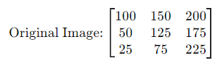

To perform the negative transformation, subtract each pixel value from 255:

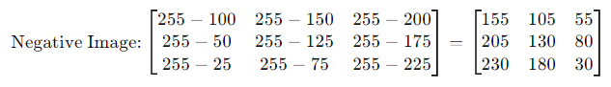In this transformed image:

* The dark areas of the original image become light, and the light areas become dark.
* For example, the pixel with an original value of 100 becomes 155 in the negative image, and a pixel with an original value of 225 becomes 30.

### Applications of Negative Transformation

* **Medical Imaging**: Inverting the colors can help in highlighting certain features in medical images, such as X-rays, where white areas might represent bones or other dense structures.
* **Photographic Effects**: Used to create artistic effects in photography by inverting the image colors.
* **Improving Visual Interpretation**: Helps in scenarios where the background is dark, and the object of interest is bright, making it easier to interpret or analyze.

### Summary

**Image enhancement** aims to improve the visual quality of an image for a specific purpose. **Negative transformation** is a simple yet effective image enhancement technique where each pixel's intensity value is inverted, which can be particularly useful for highlighting certain features in an image.

**What is frequency domain filter? Explain different types of lowpass filters.**

**Frequency Domain Filter**

A frequency domain filter is a tool used in image processing that operates on the frequency components of an image rather than its spatial representation. This type of filtering involves transforming an image from the spatial domain to the frequency domain using techniques such as the Fourier Transform. Once in the frequency domain, various filters can be applied to manipulate specific frequency components, which can help in tasks like smoothing, sharpening, and noise reduction. After applying the filter, the image is transformed back into the spatial domain using the inverse Fourier Transform.

**Types of Lowpass Filters**

Lowpass filters are designed to allow low-frequency components of an image to pass through while attenuating (reducing) high-frequency components. This results in a smoother image by removing noise and fine details. There are several types of lowpass filters:

1. **Ideal Lowpass Filter**:
   * The ideal lowpass filter completely blocks all frequencies above a specified cutoff frequency while allowing those below it to pass unchanged. Its frequency response is a rectangular function, meaning it has a sharp transition between passed and blocked frequencies. However, this filter can introduce ringing artifacts in the spatial domain due to its abrupt cutoff.
2. **Gaussian Lowpass Filter**:
   * The Gaussian lowpass filter uses a Gaussian function for its frequency response, which provides a smoother transition between passed and blocked frequencies compared to the ideal filter. This characteristic helps reduce ringing artifacts when transforming back into the spatial domain.
3. **Butterworth Lowpass Filter**:
   * The Butterworth lowpass filter is designed to have a maximally flat frequency response in the passband, meaning it does not have ripples or variations within that range. It gradually rolls off frequencies beyond its cutoff point at a defined rate determined by its order (the higher the order, the steeper the roll-off). This makes it effective for applications requiring smooth transitions without significant distortion.

In summary, lowpass filters play an essential role in image processing by controlling which frequencies are allowed through during filtering operations, thereby influencing how images appear after processing.

**---------------------------------------------------------------------------------------------------------------------**

A **frequency domain filter** is a technique used in image processing to modify or enhance an image by manipulating its frequency components. In the frequency domain, an image is represented by its frequency content rather than spatial content. This is achieved using the Fourier Transform, which decomposes an image into its constituent frequencies.

**Frequency Domain Filtering:**

1. **Transform the Image:** Convert the image from the spatial domain (where pixels represent intensity values) to the frequency domain using the Fourier Transform (typically the Fast Fourier Transform, FFT).
2. **Apply the Filter:** Modify the frequency components using a filter function that operates in the frequency domain.
3. **Inverse Transform:** Convert the filtered frequency domain image back to the spatial domain using the Inverse Fourier Transform (IFFT).

### Types of Lowpass Filters

Lowpass filters allow low-frequency components of an image to pass through while attenuating or blocking higher-frequency components. These filters are used to smooth images, reduce noise, and remove high-frequency details. Here are some common types of lowpass filters:

1. **Ideal Lowpass Filter**

**Definition:**

* + An ideal lowpass filter passes all frequencies below a certain cutoff frequency and blocks all frequencies above this cutoff.

**Characteristics:**

* + The frequency response is a perfect rectangle: 1 for frequencies below the cutoff and 0 for frequencies above the cutoff.
  + The filter introduces sharp transitions in the frequency domain, which can cause ringing artifacts in the spatial domain.

**Frequency Response:**

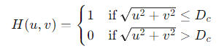​​

where Dc​ is the cutoff frequency.

1. **Butterworth Lowpass Filter**

**Definition:**

* + A Butterworth lowpass filter has a frequency response that is smooth and monotonic, with no ripples in the passband or stopband.

**Characteristics:**

* + The frequency response gradually decreases from 1 to 0, providing a smoother transition compared to the ideal filter.
  + It is characterized by its order n, which determines the rate of roll-off.

**Frequency Response:**

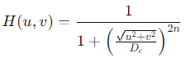

where Dc​ is the cutoff frequency and n is the filter order.

1. **Gaussian Lowpass Filter**

**Definition:**

* + A Gaussian lowpass filter uses a Gaussian function to smooth the image, providing a smooth roll-off in the frequency domain.

**Characteristics:**

* + The filter has a bell-shaped curve, which ensures smooth transitions between passband and stopband.
  + It is characterized by the standard deviation σ, which determines the width of the Gaussian function.

**Frequency Response:**



where σ is the standard deviation of the Gaussian function, and u and v are the frequency coordinates.

### Summary

* **Frequency Domain Filter:** Processes image data in the frequency domain to modify or enhance the image by manipulating its frequency components.
* **Ideal Lowpass Filter:** Passes low frequencies and blocks high frequencies with a sharp cutoff, leading to ringing artifacts.
* **Butterworth Lowpass Filter:** Provides a smooth transition between passband and stopband, with no ripples and a gradual roll-off.
* **Gaussian Lowpass Filter:** Uses a Gaussian function for smooth filtering with a bell-shaped curve, resulting in smooth transitions and less ringing artifacts.

### Application of Lowpass Filters

Lowpass filters are primarily used to remove high-frequency noise from images or to smooth an image by removing fine details (like edges). They are widely used in various image processing tasks, including:

* **Noise Reduction**: By filtering out high-frequency noise while preserving the important low-frequency information.
* **Smoothing**: To create a blurred version of an image, often as a preprocessing step before further analysis.

In practice, the choice of lowpass filter depends on the specific requirements of the task, including the need for smoothness, computational efficiency, and the level of artifact tolerance.

**Explain the Bit plane slicing technique for image enhancement.**

**Bit Plane Slicing Technique for Image Enhancement**

Bit plane slicing is a powerful technique used in digital image processing to enhance images by analyzing and manipulating the individual bits of pixel values. This method allows for a detailed examination of how each bit contributes to the overall appearance of an image, facilitating various enhancements based on the significance of these bits.

**Understanding Bit Plane Slicing**

In digital images, each pixel can be represented by a binary number. For example, an 8-bit grayscale image has pixel values ranging from 0 to 255, which can be expressed in binary as an 8-bit number (e.g., 00000000 to 11111111). The bit plane slicing technique involves separating these binary representations into individual planes, where each plane corresponds to one bit of the original pixel values.

* **Most Significant Bit (MSB)**: The leftmost bit in the binary representation, which holds the highest value and contributes significantly to the overall brightness or intensity of the pixel.
* **Least Significant Bit (LSB)**: The rightmost bit, which has the lowest value and typically contributes less to the perceived image quality.

By isolating these bits into separate planes, we can analyze their contributions to the image’s visual characteristics.

**Process of Bit Plane Slicing**

1. **Convert Pixel Values to Binary**: Each pixel’s decimal value is converted into its binary form.
2. **Extract Bit Planes**: Each bit from the binary representation is extracted and assigned to a separate plane. For an 8-bit image, this results in eight different planes.
3. **Create Binary Images for Each Plane**: Each extracted bit plane is represented as a binary image where pixels are either set to 1 (indicating presence) or 0 (indicating absence) based on whether that specific bit is set in the original pixel value.

**Image Enhancement Using Bit Plane Slicing**

The enhancement capabilities of bit plane slicing stem from its ability to isolate significant features within an image:

* **Noise Reduction**: By focusing on higher-order bit planes (such as MSB), we can reduce noise since these planes contain more critical information about edges and prominent features while lower-order planes may contain random noise.
* **Detail Emphasis**: Conversely, lower-order planes can be analyzed separately to enhance subtle details that might be lost when viewing only higher-order bits.
* **Compression and Storage Efficiency**: Since not all bits contribute equally to visual quality, certain less significant planes can be discarded or compressed more aggressively without significantly affecting perceived quality.

For instance, if we focus on enhancing edge detection in an image, we would primarily utilize the MSB because it carries most of the important structural information. On the other hand, if we want to highlight textures or subtle variations in shading, we might analyze lower-order bits.

**Applications of Bit Plane Slicing**

Bit plane slicing finds applications across various fields including:

* **Medical Imaging**: Enhancing features in scans such as MRI or CT images.
* **Remote Sensing**: Analyzing satellite images for environmental monitoring.
* **Digital Forensics**: Identifying tampered images by examining changes across different bit planes.

In conclusion, bit plane slicing serves as a vital tool in image enhancement by allowing practitioners to manipulate and analyze individual bits within pixel values effectively. This capability leads not only to improved visual quality but also aids in efficient data storage and processing.

**---------------------------------------------------------------------------------------------------------------------**

### Bit Plane Slicing Technique for Image Enhancement

**Bit plane slicing** is an image processing technique used to analyze and enhance specific details in a digital image. It involves breaking down an image into its binary components, known as **bit planes**, and manipulating these planes to enhance certain features within the image.

### Understanding Bit Planes

A grayscale image is typically represented with 8 bits per pixel (for an 8-bit image), which means each pixel can have a value ranging from 0 to 255. In binary form, these values can be represented as 8 bits (a byte). Each bit in this 8-bit representation contributes to the overall intensity of the pixel, with the most significant bit (MSB) having the highest value and the least significant bit (LSB) having the lowest.

For example, a pixel with an intensity value of 150 in an 8-bit image can be represented as:

15010 = 100101102​

This binary number can be decomposed into 8 bits, each representing a **bit plane**:

* **Bit Plane 7** (MSB): 1
* **Bit Plane 6**: 0
* **Bit Plane 5**: 0
* **Bit Plane 4**: 1
* **Bit Plane 3**: 0
* **Bit Plane 2**: 1
* **Bit Plane 1**: 1
* **Bit Plane 0** (LSB): 0

### Concept of Bit Plane Slicing

In **bit plane slicing**, the image is decomposed into its 8 bit planes. Each bit plane is a binary image representing the presence (1) or absence (0) of that bit in the pixel values. The bit planes can be visualized separately or manipulated individually to enhance specific features in the image.

* **Higher bit planes (e.g., Bit Plane 7, 6)** contain the most significant information, including the overall structure and major intensity variations of the image.
* **Lower bit planes (e.g., Bit Plane 0, 1)** contain finer details and noise.

### Image Enhancement Using Bit Plane Slicing

1. **Isolating High-Order Bit Planes**:
   * The higher-order bit planes (e.g., Bit Plane 7, 6) are extracted and combined to enhance the major structural features of the image. This is because these planes contain the most important information about the image's appearance.
   * For example, by isolating and visualizing only the 7th bit plane, you can emphasize the most prominent features of the image while ignoring finer details and noise.
2. **Highlighting Fine Details**:
   * The lower-order bit planes (e.g., Bit Plane 1, 0) can be used to highlight fine details in the image, which might not be as prominent in the higher-order planes. However, these planes might also contain more noise.
3. **Combining Multiple Bit Planes**:
   * By selectively combining different bit planes, you can create a composite image that enhances certain features while suppressing others. For example, combining the 7th and 6th bit planes might produce an image with both strong structural features and some fine details.

### Example

Consider an 8-bit grayscale image with the following pixel values:

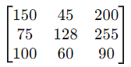

The binary representation for each pixel value can be decomposed into 8 bit planes. For instance:

* **Pixel value 150**: 100101102​
* **Pixel value 45**: 001011012​

Each bit plane can be isolated:

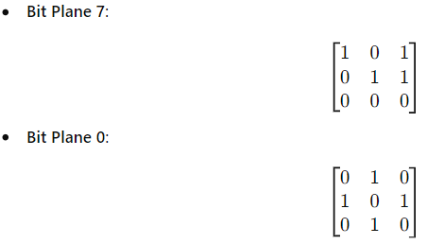

In this case, if you were to visualize just Bit Plane 7, you would see a rough outline of the image's major structures, while Bit Plane 0 would show finer details and potentially more noise.

### Applications of Bit Plane Slicing

* **Image Compression**: By focusing on the higher bit planes, lower bit planes can be discarded or compressed more aggressively, reducing data size while preserving important image information.
* **Image Watermarking**: Watermarks can be embedded in the lower bit planes, making them less noticeable while still detectable.
* **Feature Enhancement**: Enhancing specific features in an image by manipulating individual bit planes.

### Summary

**Bit plane slicing** is an image enhancement technique that involves breaking down an image into its constituent bit planes and manipulating these planes to highlight or suppress certain features. By isolating and processing specific bit planes, one can enhance the image's overall structure, highlight fine details, or reduce noise, making it a versatile tool in image processing.

**Explain sampling and quantization.**

### Sampling and Quantization

**Sampling** and **quantization** are fundamental processes in digital image processing and digital signal processing. They are essential for converting continuous signals (like analog images or audio) into discrete digital representations that can be processed by computers.

### Sampling

**Sampling** is the process of converting a continuous signal into a discrete signal by measuring the signal at specific intervals. In the context of digital image processing, sampling refers to selecting a set of discrete points from a continuous image to form a digital representation.

#### How Sampling Works:

1. **Continuous Image**: An image in its original form is continuous and has an infinite number of pixel values.
2. **Discrete Grid**: To digitize the image, we sample it by selecting discrete points based on a regular grid or lattice structure. Each point in this grid corresponds to a pixel in the digital image.

For example, an image with high resolution can be sampled at regular intervals to reduce its resolution, creating a digital image with fewer pixels but still retaining key features.

#### Key Concepts:

* **Sampling Rate**: The frequency at which samples are taken. In image processing, this is related to the resolution of the image (e.g., 1920x1080 pixels).
* **Sampling Interval**: The distance between adjacent sampling points. Smaller intervals mean higher resolution and more detail.

**Example**: If you have a photograph and you want to convert it into a digital format, you sample the continuous image at regular intervals to create a grid of pixels. Each pixel represents the color and intensity at that specific point.

### Quantization

**Quantization** is the process of mapping a large set of input values (or continuous range) to a smaller set of output values. In digital image processing, quantization involves converting the continuous range of pixel values into discrete levels.

#### How Quantization Works:

1. **Discrete Pixel Values**: After sampling, each pixel has a continuous value (in the case of grayscale, a value between 0 and 255 for an 8-bit image).
2. **Quantization Levels**: These continuous values are mapped to a finite number of levels. For example, in an 8-bit grayscale image, pixel values are quantized to 256 discrete levels ranging from 0 to 255.

#### Key Concepts:

* **Bit Depth**: Determines the number of quantization levels. An 8-bit image has 256 levels, while a 16-bit image has 65,536 levels.
* **Quantization Error**: The difference between the actual value and the quantized value. This error is also known as rounding error and can lead to loss of detail or distortion.

**Example**: For an 8-bit grayscale image, quantization maps continuous pixel values into 256 discrete levels. A pixel with a value of 127.5 might be quantized to 127 or 128, depending on the rounding method used.

### Summary

* **Sampling**:
  + Converts a continuous signal into a discrete set of points.
  + Involves selecting a set of discrete pixel locations from a continuous image.
  + Determines the spatial resolution of the digital image.
* **Quantization**:
  + Converts continuous pixel values into discrete levels.
  + Maps pixel values to a finite number of levels based on the bit depth.
  + Determines the color depth and the range of intensity levels in the digital image.

Both sampling and quantization are critical steps in digitizing images and signals, enabling them to be stored, processed, and analyzed in digital form.

**What do you mean by image enhancement? What is Histogram Modeling? Explain with example.**

**What is Image Enhancement?**

Image enhancement refers to the process of improving the visual appearance of an image or converting it into a form that is more suitable for analysis. The goal of image enhancement is to make certain features of the image more prominent, thereby facilitating better interpretation and understanding. This can involve various techniques that manipulate the pixel values in an image to achieve desired results. Common methods include adjusting brightness and contrast, applying filters, and transforming color spaces.

The importance of image enhancement spans multiple fields such as medical imaging, remote sensing, photography, and computer vision. For instance, in medical imaging, enhanced images can help radiologists identify abnormalities more easily. In photography, enhancements can improve aesthetic appeal.

**What is Histogram Modeling?**

Histogram modeling is a technique used in image processing to analyze and modify the distribution of pixel intensities in an image. A histogram represents the frequency distribution of pixel values (intensities) within an image. Each bin in the histogram corresponds to a range of intensity values, while the height of each bin indicates how many pixels fall within that range.

Histogram modeling involves manipulating this histogram to achieve specific enhancement goals. There are several common operations associated with histogram modeling:

1. **Histogram Equalization**: This technique aims to distribute pixel intensities uniformly across the available range. By doing so, it enhances contrast in images where certain intensity levels are underrepresented.
2. **Histogram Specification**: Also known as histogram matching, this method modifies the histogram of one image to match that of another reference image. This can be useful when trying to standardize images taken under different lighting conditions.
3. **Contrast Stretching**: This approach expands the range of intensity levels present in an image by stretching them over a wider range.

**Example of Histogram Modeling**

To illustrate histogram modeling, consider a grayscale image where most pixel values are clustered around mid-tone gray (e.g., 128 on a scale from 0-255). The corresponding histogram would show high frequencies around this value and low frequencies at both extremes (0 and 255).

1. **Original Histogram**:
   * Suppose you have an original histogram where most pixels are between 100 and 150.
   * The resulting image may appear dull or lacking contrast because there are not enough dark or bright areas.
2. **Applying Histogram Equalization**:
   * When you apply histogram equalization to this image, you redistribute pixel intensities so that they cover the entire range from 0 to 255.
   * After equalization, you might find that dark areas become darker and bright areas become brighter.
   * The new histogram will be more uniform across all intensity levels.
3. **Resulting Image**:
   * The enhanced image will now display improved contrast with clearer distinctions between different features.
   * For example, if this was a medical scan showing tissues, important details like edges or anomalies may become more visible due to enhanced contrast.

In summary, through techniques like histogram equalization within the framework of histogram modeling, we can significantly enhance images for better visual interpretation or analysis.

**---------------------------------------------------------------------------------------------------------------------**

### Image Enhancement

Image enhancement is the process of improving the visual quality of an image, making it more suitable for a specific application or simply more pleasing to the human eye. The goal is to accentuate certain features of the image or remove unwanted noise and artifacts. Enhancement techniques can be broadly categorized into spatial domain methods (which directly operate on pixel values) and frequency domain methods (which operate on the image's frequency components).

**Common Image Enhancement Techniques:**

1. **Contrast Adjustment:** Enhancing the contrast to make objects within the image more distinguishable.
2. **Smoothing:** Reducing noise by averaging pixel values.
3. **Sharpening:** Enhancing edges to make details more distinct.
4. **Histogram Equalization:** Spreading out the most frequent intensity values, which enhances the contrast of the image.

#### Example of Image Enhancement

Consider a low-contrast image where the objects of interest are hard to distinguish. By applying contrast enhancement (e.g., histogram equalization), the difference between light and dark areas is increased, making the objects more visible.

### Histogram Modeling

Histogram modeling is a technique used in image processing to manipulate the histogram of an image to achieve a desired outcome. The histogram of an image is a graphical representation of the distribution of pixel intensities. By modifying this histogram, you can enhance specific features of an image, such as its contrast.

**Common Histogram Modeling Techniques:**

1. **Histogram Equalization:** This technique enhances the contrast of the image by spreading out the most frequent intensity values. It flattens and stretches the dynamic range of the histogram.
2. **Histogram Matching (Specification):** This technique transforms the histogram of an image to match a given histogram. It is useful when you want an image to have a specific contrast or brightness characteristic.

#### Example of Histogram Equalization

Let's take an example to illustrate histogram equalization:

* **Original Image:** Suppose you have an image where most pixel values are clustered in a narrow range (e.g., between 100 and 150 on a scale of 0-255). This would result in a low-contrast image, as the difference between the darkest and lightest areas is small.
* **Histogram of Original Image:** The histogram would show a peak in the range 100-150, with very few pixels in other intensity ranges.
* **After Histogram Equalization:** The pixel values are spread out across the full range (0-255). The histogram becomes more uniform, leading to a higher contrast image where details in both dark and bright areas are more visible.

### Practical Example in Python

Here’s a simple example using Python and the OpenCV library to apply histogram equalization:

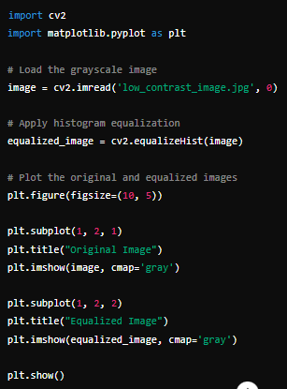

This code reads a low-contrast grayscale image, applies histogram equalization, and then displays both the original and equalized images side by side. The equalized image will typically show improved contrast, making details more apparent.

**Summary**

* **Image Enhancement:** Techniques used to improve the visual quality of an image by adjusting its features and contrast.
* **Histogram Modeling:** A method for enhancing images by manipulating their histograms. This includes techniques like histogram equalization and specification to improve contrast and match desired intensity distributions.

**What is zooming? Explain the process of zooming by interpolation method.**

**What is Zooming?**

Zooming refers to the process of enlarging an image so that its details become more visible and clearer. This technique is widely used in various applications, from optical zooming through camera lenses to digital zooming in image processing software. In digital image processing, zooming involves manipulating pixels to increase the size of an image while attempting to maintain or enhance its quality.

**Process of Zooming by Interpolation Method**

Interpolation methods are techniques used to estimate new pixel values when enlarging an image. The goal is to create a smooth transition between pixels, minimizing blurriness and preserving detail as much as possible. There are several interpolation methods, but here we will focus on three common ones: Pixel Replication (Nearest Neighbor Interpolation), Zero-Order Hold, and K-Times Zooming.

1. **Pixel Replication (Nearest Neighbor Interpolation)**:
   * **Methodology**: In this method, each pixel in the original image is simply replicated multiple times to create a larger image. For example, if you have a 2x2 pixel image and want to zoom it by a factor of 2, each pixel will be duplicated twice both row-wise and column-wise.
   * **Example**:

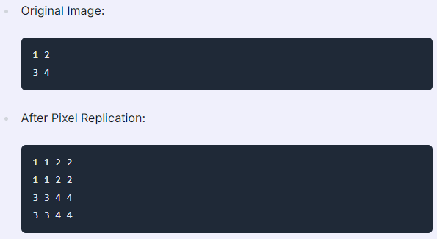

* + - After Pixel Replication:

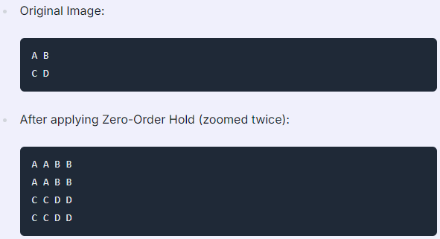

* + **Advantages**: This method is simple and easy to implement.
  + **Disadvantages**: The resulting image can appear very blurry as the zoom factor increases because it does not introduce any new pixel information.

1. **Zero-Order Hold**:
   * **Methodology**: This method works by taking two adjacent pixels, averaging them, and placing the average value between them. It can only zoom by powers of two (e.g., doubling).
   * **Example**:

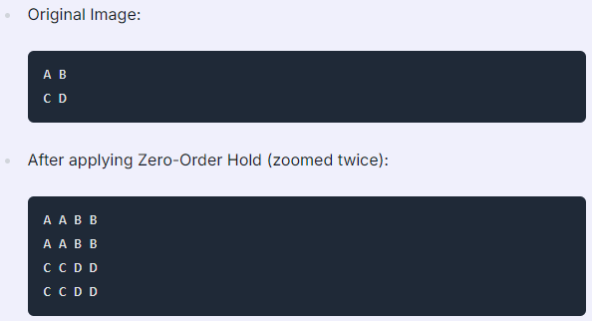

* + **Advantages**: Produces less blurry images compared to pixel replication.
  + **Disadvantages**: Limited to zoom factors that are powers of two.

1. **K-Times Zooming**:
   * **Methodology**: This method allows for arbitrary zoom factors (K). It involves calculating intermediate pixel values based on adjacent pixels. For instance, you take two neighboring pixels, find their difference, divide it by K, and then insert new values accordingly.
   * **Example**:

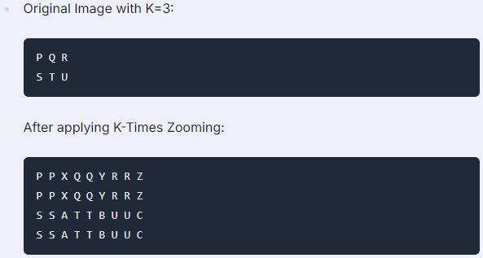

In conclusion, interpolation methods for zooming aim to enlarge images while maintaining clarity and reducing blurriness through various mathematical techniques applied during the enlargement process.

**---------------------------------------------------------------------------------------------------------------------**

**Zooming** in image processing refers to increasing the size or resolution of an image. This process enlarges the image to make details more visible or to fit a larger display area. However, simply enlarging an image by duplicating pixels would result in a blocky, low-quality image. To achieve a smooth, high-quality zoomed image, interpolation methods are used.

### Interpolation Method for Zooming

Interpolation is the process of estimating unknown pixel values within the image when zooming. It uses known pixel values around the point of interest to estimate the new pixel values. There are several interpolation methods commonly used for zooming:

1. **Nearest-Neighbor Interpolation**
2. **Bilinear Interpolation**
3. **Bicubic Interpolation**

#### 1. Nearest-Neighbor Interpolation

This is the simplest interpolation method. It assigns the value of the nearest known pixel to the unknown pixel.

* **Advantages:**
  + Fast and computationally inexpensive.
  + Simple to implement.
* **Disadvantages:**
  + Can produce blocky or pixelated images.
  + Low quality, especially when scaling up significantly.

**Process:**

* For each pixel in the zoomed image, find the nearest pixel in the original image and assign its value to the new pixel.

#### 2. Bilinear Interpolation

Bilinear interpolation considers the closest 2x2 neighborhood of known pixel values surrounding the unknown pixel. It takes a weighted average of these four pixels to determine the new pixel value.

* **Advantages:**
  + Produces smoother images compared to nearest-neighbor.
  + Reduces the blocky effect.
* **Disadvantages:**
  + Still relatively simple but can introduce blurring.

**Process:**

* For each pixel in the zoomed image:
  1. Identify the 2x2 block of pixels in the original image surrounding the target location.
  2. Calculate the pixel's value as a weighted average of these four pixels based on the distance of the target location from them.

#### 3. Bicubic Interpolation

Bicubic interpolation uses the closest 4x4 neighborhood of pixels to compute the new pixel value, resulting in even smoother and higher-quality images.

* **Advantages:**
  + Produces the highest quality image of the three methods.
  + Smoother gradients and better preservation of details.
* **Disadvantages:**
  + More computationally expensive.
  + Slower than nearest-neighbor and bilinear interpolation.

**Process:**

* For each pixel in the zoomed image:
  1. Identify the 4x4 block of pixels surrounding the target location in the original image.
  2. Apply a cubic polynomial to the pixel values, considering the distance of the target location from the surrounding pixels.
  3. Assign the computed value to the pixel in the zoomed image.

### Example in Python Using OpenCV

Let’s consider a practical example to zoom an image using bilinear interpolation:

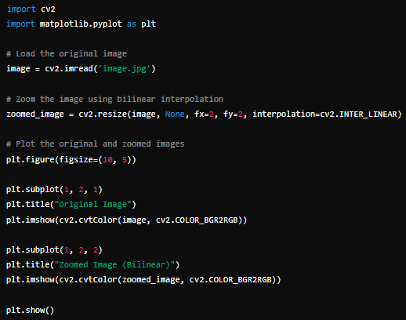

This code loads an image, zooms it by a factor of 2 using bilinear interpolation, and then displays the original and zoomed images side by side. The zoomed image will be smoother and of higher quality compared to nearest-neighbor interpolation.

### Summary

Zooming in image processing involves enlarging an image, typically using interpolation methods to estimate the values of new pixels created during the process. Nearest-neighbor interpolation is fast but produces blocky images, while bilinear and bicubic interpolation produce smoother, higher-quality images at the cost of increased computational complexity.

**Explain how you can convert an analog image into a digital image? How many images of size 1400x1200 with 256 gray levels can be store in a 2000 MB storage space?**

**Converting an Analog Image to a Digital Image**

The process of converting an analog image into a digital image involves several key steps, which can be broken down as follows:

1. **Image Capture**: The first step in the conversion process is capturing the analog image using a device such as a scanner or a digital camera. In this stage, light from the scene is focused onto a photosensitive surface (like film or a CCD sensor), which generates an electrical signal proportional to the intensity of light.
2. **Sampling**: Once the image is captured, it must be sampled. Sampling refers to measuring the intensity of light at discrete intervals across the image. This process determines how many pixels will represent the image. The more samples taken, the higher the resolution of the resulting digital image.
3. **Quantization**: After sampling, each sampled value must be quantized. Quantization involves mapping the continuous range of intensity values (in this case, gray levels) to discrete values that can be represented digitally. For example, if we are using 256 gray levels, each pixel’s intensity will be assigned one of these 256 possible values.
4. **Encoding**: The final step is encoding these quantized values into a binary format that can be stored and processed by computers. Each gray level can typically be represented using 8 bits (since 28 = 256), allowing for efficient storage and manipulation of images.
5. **Storage**: The digital image is then stored in a file format suitable for use on computers (such as JPEG, PNG, BMP). This file format dictates how data is organized and compressed for storage efficiency.

Now let’s calculate how many images of size 1400x1200 with 256 gray levels can be stored in a 2000 MB storage space.

**Step-by-Step Calculation**

1. **Determine Image Size in Pixels**:
   * An image with dimensions 1400x1200 has:

Total Pixels = 1400×1200 = 1,680,000pixels

1. **Determine Bits per Pixel**:
   * With 256 gray levels, each pixel requires:

Bits per Pixel = log2(256) = 8bits

1. **Calculate Total Bits for One Image**:
   * Therefore, one image would require:

Total Bits = 1,680,000pixels × 8bits/pixel = 13,440,000bits

1. **Convert Bits to Bytes**:
   * Since there are 8 bits in a byte:

Total Bytes = $\frac{13,440,000 }{8}$ = 1,680,000bytes

1. **Convert Bytes to Megabytes**:
   * To convert bytes to megabytes (where 1 MB =1,0242 bytes):

Total MB per Image = $\frac{1,680,000 }{10242}$ ≈ 1.60MB

1. **Calculate Number of Images that Can Be Stored in 2000 MB**:
   * Finally, we divide the total storage capacity by the size of one image:

Number of Images = $\frac{2000 }{1.60}$ ≈ 1250

Thus,**The number of images of size 1400x1200 with 256 gray levels that can be stored in a 2000 MB storage space is approximately:** **1250**

**---------------------------------------------------------------------------------------------------------------------**

### Converting an Analog Image to a Digital Image

The process of converting an analog image into a digital image involves two main steps: **sampling** and **quantization**.

#### 1. Sampling

Sampling is the process of converting the continuous signal (analog image) into discrete signals by dividing the image into a grid of pixels. Each pixel represents a small portion of the image. The sampling rate determines the resolution of the digital image; higher sampling rates result in higher resolution images.

* **Higher Sampling Rate:** More pixels per unit area, leading to a more detailed digital image.
* **Lower Sampling Rate:** Fewer pixels per unit area, leading to a less detailed image.

#### 2. Quantization

Quantization involves assigning a discrete value (from a finite set of values) to each sampled pixel. In the context of grayscale images, this value corresponds to the intensity level of the pixel.

* **Gray Levels:** The number of discrete intensity levels is often a power of 2. For example, an 8-bit grayscale image can have 256 (28) different gray levels.
* **Higher Quantization Levels:** More intensity levels, resulting in smoother transitions between shades of gray.
* **Lower Quantization Levels:** Fewer intensity levels, leading to a more pixelated or posterized image.

### Storage Calculation for Digital Images

To determine how many images of size 1400x1200 pixels with 256 gray levels can be stored in a 2000 MB storage space, we first calculate the storage required for one image.

#### Step 1: Calculate the Number of Pixels

An image of size 1400x1200 pixels has:

Total Pixels = 1400×1200 = 1,680,000 pixels

#### Step 2: Determine the Bits per Pixel

Since the image has 256 gray levels, each pixel requires 8 bits (since 28 = 256).

#### Step 3: Calculate the Total Storage Required for One Image

The storage required for one image is given by:

Storage per Image = Total Pixels × Bits per Pixel = 1,680,000 × 8 bits

Convert bits to bytes:



Convert bytes to megabytes:



#### Step 4: Calculate the Number of Images That Can Be Stored

Given a storage space of 2000 MB:



### Summary

* **Analog to Digital Conversion:** Involves sampling (dividing the image into pixels) and quantization (assigning discrete intensity values to each pixel).
* **Storage Calculation:** For a 1400x1200 pixel image with 256 gray levels (8 bits per pixel), approximately 1250 images can be stored in a 2000 MB storage space.

**What is image compression?**

**Image compression** is the process of reducing the size of an image file while maintaining as much of the original quality as possible. The primary goal of image compression is to minimize the amount of storage space required to save the image and reduce the bandwidth needed for transmission over networks.

### Types of Image Compression

Image compression can be categorized into two main types:

1. **Lossy Compression**
   * **Definition:** In lossy compression, some of the image data is lost during compression. This means that the decompressed image may not be identical to the original, but the loss of quality is often imperceptible to the human eye.
   * **Advantages:** Provides higher compression ratios, significantly reducing file sizes.
   * **Common Formats:** JPEG (Joint Photographic Experts Group), WebP, and some implementations of PNG.
   * **Example:** JPEG compression uses techniques like quantization and discrete cosine transform (DCT) to reduce file size by discarding less important data.
2. **Lossless Compression**
   * **Definition:** In lossless compression, the image data is compressed without any loss of quality. The decompressed image is identical to the original.
   * **Advantages:** Preserves all the original image data, which is important for applications requiring exact reproduction.
   * **Common Formats:** PNG (Portable Network Graphics), GIF (Graphics Interchange Format), and TIFF (Tagged Image File Format).
   * **Example:** PNG compression uses methods like filtering and entropy encoding (e.g., DEFLATE) to reduce file size while preserving the original image data.

### Compression Techniques

1. **Transform Coding**
   * **Description:** Converts the image into a different domain where it is easier to compress. The Discrete Cosine Transform (DCT) is a common technique used in JPEG compression.
   * **Example:** In JPEG, the image is divided into 8x8 blocks, and DCT is applied to each block. The result is then quantized and encoded.
2. **Quantization**
   * **Description:** Reduces the precision of the image data. In lossy compression, this involves approximating the values of the image pixels to reduce the amount of data needed.
   * **Example:** In JPEG, quantization reduces the number of bits used to represent each coefficient in the DCT-transformed image, leading to loss of detail but a smaller file size.
3. **Entropy Coding**
   * **Description:** Compresses the data based on the frequency of occurrence of different values. It encodes more frequent values with shorter codes and less frequent values with longer codes.
   * **Example:** Huffman coding and Arithmetic coding are common entropy coding methods used in various image compression algorithms.
4. **Run-Length Encoding (RLE)**
   * **Description:** Compresses sequences of the same pixel value by storing the value and the count of its repetitions.
   * **Example:** Used in bitmap images and simple formats like GIF.

### Applications of Image Compression

1. **Web and Internet:** Reduces image file sizes for faster loading times and efficient use of bandwidth.
2. **Digital Photography:** Compresses images to save storage space on cameras and smartphones.
3. **Multimedia and Streaming:** Compresses images and video content for efficient transmission and storage.
4. **Medical Imaging:** Balances between quality and file size to manage large volumes of medical images.

### Summary

* **Image Compression:** Reduces the size of an image file to save storage space and reduce transmission bandwidth.
* **Lossy vs. Lossless Compression:**
  + **Lossy:** Reduces file size by removing some data (e.g., JPEG).
  + **Lossless:** Compresses without losing any data (e.g., PNG).
* **Techniques:** Includes transform coding, quantization, entropy coding, and run-length encoding.
* **Applications:** Used in web images, digital photography, multimedia, and medical imaging.

**What do you understand by image restoration? Explain how it is different from image enhancement.**

**Image Restoration vs. Image Enhancement**

**Understanding Image Restoration**

Image restoration is a process aimed at recovering an original image that has been degraded by various factors such as noise, blur, or other distortions. The primary goal of image restoration is to reverse the degradation process and recover the lost information in the image. This involves using mathematical models and algorithms to estimate what the original image would look like before it was altered. Techniques commonly employed in image restoration include:

1. **Deconvolution**: This method is used to reverse the effects of blurring caused by camera motion or out-of-focus optics. It involves estimating the point spread function (PSF) that describes how a point source of light is blurred.
2. **Denoising**: Noise can be introduced during image acquisition due to sensor limitations, environmental conditions, or transmission errors. Denoising techniques aim to remove this unwanted noise while preserving important features of the image.
3. **Inpainting**: This technique fills in missing or corrupted parts of an image based on surrounding pixel information, effectively reconstructing areas that have been lost.
4. **Restoration Algorithms**: Various algorithms such as Wiener filtering, total variation minimization, and Bayesian methods are utilized to restore images by estimating the original signal from the degraded version.

The effectiveness of these methods often relies on prior knowledge about the nature of degradation and statistical properties of both the noise and the original image.

**Understanding Image Enhancement**

Image enhancement, on the other hand, refers to techniques aimed at improving the visual appearance of an image or making certain features more discernible without necessarily recovering any lost information from a degraded state. The focus here is on subjective quality improvement rather than objective recovery of data. Common techniques for image enhancement include:

1. **Contrast Adjustment**: Enhancing contrast can make details more visible by stretching pixel intensity values across a wider range.
2. **Histogram Equalization**: This technique redistributes pixel intensity values so that they cover a broader spectrum, enhancing overall contrast and visibility.
3. **Sharpening**: Methods such as unsharp masking increase edge contrast in an image, making it appear sharper and clearer.
4. **Color Correction**: Adjusting colors to correct for lighting conditions or enhance specific hues can improve visual appeal without altering underlying data integrity.

While both processes may use similar tools and algorithms (e.g., filters), their objectives are fundamentally different—restoration seeks to recover lost data while enhancement aims to improve visual quality.

**Key Differences Between Image Restoration and Image Enhancement**

1. **Objective**:
   * Restoration focuses on recovering original content.
   * Enhancement aims at improving visual quality.
2. **Data Integrity**:
   * Restoration attempts to maintain data integrity by reversing degradation.
   * Enhancement may alter data for better appearance without concern for accuracy.
3. **Techniques Used**:
   * Restoration employs algorithms designed for recovery (e.g., deconvolution).
   * Enhancement uses techniques focused on visual perception (e.g., contrast adjustment).
4. **Applications**:
   * Restoration is often used in fields like medical imaging, satellite imagery, and archival photography where accurate representation is crucial.
   * Enhancement finds applications in photography, video production, and graphic design where aesthetics are prioritized over strict fidelity to original data.

In summary, while both image restoration and enhancement play significant roles in digital imaging processes, they serve distinct purposes with different methodologies aimed at either recovering lost information or improving visual presentation.

--------------------------------------------------------------------------------------------------------------------

### Image Restoration

**Image Restoration** refers to the process of reconstructing or recovering an image that has been degraded by various factors such as noise, blurring, or other distortions. The primary goal of image restoration is to recover the original image as accurately as possible by reversing the degradation process.

Degradations can occur due to:

* **Noise:** Random variations in pixel intensity.
* **Blur:** Caused by camera motion, defocusing, or long exposure.
* **Geometric Distortions:** Caused by the imaging system or the environment.

**Techniques Used in Image Restoration:**

1. **Deconvolution:** A method to reverse the effects of blurring by applying an inverse filter or a Wiener filter.
2. **Noise Reduction Filters:** Such as Gaussian filters, median filters, or more advanced methods like wavelet denoising.
3. **Image Inpainting:** Used to fill in missing or damaged parts of an image.

#### Example of Image Restoration:

* **Blurry Image Restoration:** Given a blurred image due to camera shake, deconvolution can be applied to sharpen the image and restore it closer to its original form.

### Image Enhancement

**Image Enhancement** focuses on improving the visual appearance of an image or making certain features more distinguishable. Unlike restoration, enhancement does not aim to reverse specific degradation effects but rather to make the image more visually appealing or easier to interpret.

**Techniques Used in Image Enhancement:**

1. **Contrast Adjustment:** Improves visibility by stretching the range of intensity values.
2. **Histogram Equalization:** Enhances contrast by redistributing the intensity values.
3. **Sharpening:** Increases the visibility of edges and fine details.
4. **Noise Addition (Deliberate):** In some cases, noise is added to make an image look more natural (e.g., adding film grain to a digital photo).

#### Example of Image Enhancement:

* **Low-Contrast Image Enhancement:** Applying histogram equalization to an image with low contrast to make the details more visible.

### Key Differences Between Image Restoration and Image Enhancement

1. **Objective:**
   * **Image Restoration:** Aims to recover the original image by removing or mitigating the effects of degradation.
   * **Image Enhancement:** Focuses on improving the visual quality of an image, making it more suitable for display or analysis, without necessarily recovering the original content.
2. **Approach:**
   * **Image Restoration:** Requires knowledge or assumptions about the degradation process (e.g., type of noise, blurring function).
   * **Image Enhancement:** Does not rely on any specific model of degradation and is often applied to images that are already in an acceptable state but need visual improvement.
3. **Application:**
   * **Image Restoration:** Used in applications where accuracy is critical, such as medical imaging, satellite image processing, or forensic analysis.
   * **Image Enhancement:** Commonly used in photography, television broadcasting, and consumer imaging to improve the subjective quality of images.

### Summary

* **Image Restoration** is about recovering the original image from a degraded version by reversing the degradation process. It focuses on accuracy and is often used in critical applications.
* **Image Enhancement** is about improving the visual appeal or clarity of an image. It does not aim to recover the original image but to make it more visually pleasing or easier to analyze.

**Define image degradation and restoration. Explain the noise models with its effecting nature in degrading the image.**

**Image Degradation and Restoration**

**Definition of Image Degradation**

Image degradation refers to the process through which an image loses its quality due to various factors, leading to a decline in its visual clarity and information content. This degradation can occur due to several reasons, including but not limited to noise, blurring, compression artifacts, and environmental conditions during image capture. The result is often a distorted or less informative representation of the original scene.

**Definition of Image Restoration**

Image restoration is the process of recovering an image that has been degraded by applying various techniques aimed at reversing or mitigating the effects of degradation. The goal of restoration is to enhance the quality of the image so that it closely resembles the original scene as captured before any degradation occurred. Techniques used in image restoration include filtering methods (such as Wiener filtering), deconvolution, interpolation, and more advanced approaches like machine learning algorithms.

**Noise Models and Their Effects on Image Degradation**

Noise is one of the primary factors contributing to image degradation. It can be defined as random variations in brightness or color information in images that do not correspond to actual changes in the scene being captured. Various noise models exist, each with distinct characteristics and effects on images:

1. **Gaussian Noise**
   * **Nature:** Gaussian noise follows a normal distribution and is characterized by its bell-shaped curve. It typically arises from sensor noise in cameras.
   * **Effect on Images:** This type of noise adds a grainy texture to images, reducing contrast and making it difficult to distinguish fine details.
2. **Salt-and-Pepper Noise**
   * **Nature:** Salt-and-pepper noise consists of randomly occurring white and black pixels scattered throughout an image.
   * **Effect on Images:** This type of noise can obscure important features within an image, making it appear speckled or corrupted.
3. **Poisson Noise**
   * **Nature:** Poisson noise arises from photon counting statistics; it is prevalent in low-light imaging situations where light levels are low.
   * **Effect on Images:** This type of noise leads to variations in pixel intensity that are proportional to the square root of the signal intensity, resulting in graininess especially noticeable in darker areas.
4. **Speckle Noise**
   * **Nature:** Speckle noise occurs primarily in coherent imaging systems such as ultrasound or synthetic aperture radar.
   * **Effect on Images:** It manifests as granular interference patterns that can obscure fine details and reduce overall image quality.
5. **Quantization Noise**
   * **Nature:** Quantization noise results from rounding errors when converting analog signals into digital form during sampling.
   * **Effect on Images:** This leads to banding artifacts where smooth gradients appear stepped rather than continuous.

Each type of noise affects images differently based on its statistical properties and how it interacts with the underlying signal. Understanding these models helps in developing effective restoration techniques tailored for specific types of degradation.

In summary, both image degradation and restoration are critical concepts within digital imaging fields such as photography, medical imaging, remote sensing, and computer vision. By understanding various noise models and their effects on images, practitioners can apply appropriate restoration techniques to recover high-quality images from degraded ones.

### Summary

* **Image Degradation** is the process by which the quality of an image deteriorates due to various factors like noise, blur, or distortions.
* **Image Restoration** is the process of reversing this degradation to recover the original, undistorted image.
* **Noise Models:** Different types of noise (Gaussian, Salt-and-Pepper, Poisson, and Speckle) degrade images in different ways, each requiring specific restoration techniques to effectively mitigate the impact on image quality.

**Explain the region growing technique for image segmentation. What are the problems associated with it.**

**Region Growing Technique for Image Segmentation**

**Introduction to Region Growing**

Region growing is a pixel-based image segmentation technique that involves the grouping of adjacent pixels or sub-regions into larger regions based on predefined criteria. This method is particularly useful in identifying and isolating areas within an image that share similar characteristics, such as color, intensity, or texture. The process begins with one or more seed points, which are selected based on certain criteria, and then expands these seeds into larger regions by adding neighboring pixels that meet the similarity criteria.

**Steps Involved in Region Growing**

1. **Selection of Seed Points**: The first step in the region growing process is to select one or more initial seed points from the image. These points can be chosen manually by a user or automatically using algorithms that identify prominent features in the image.
2. **Defining Similarity Criteria**: After selecting the seed points, it is essential to define the criteria for similarity that will determine whether neighboring pixels should be included in the growing region. Common criteria include color similarity (e.g., RGB values), intensity differences, or texture features.
3. **Growing Process**: Starting from the seed point(s), the algorithm examines neighboring pixels (usually 4-connected or 8-connected neighbors) to check if they meet the defined similarity criteria. If a neighboring pixel meets these criteria, it is added to the current region.
4. **Iteration**: This process continues iteratively; each time new pixels are added to the region, their neighbors are checked again for inclusion until no more pixels can be added that meet the similarity condition.
5. **Termination Condition**: The algorithm terminates when no additional pixels can be added to any of the existing regions based on the defined similarity criteria.
6. **Post-processing**: After segmentation, post-processing techniques may be applied to refine and enhance segmented regions further.

**Advantages of Region Growing**

* **Flexibility**: Region growing can adapt to various types of images and can segment complex structures effectively.
* **Simplicity**: The concept behind region growing is straightforward and easy to implement.
* **Local Information Utilization**: It uses local information about pixel connectivity and similarity, making it effective for images with homogeneous regions.

**Problems Associated with Region Growing**

Despite its advantages, region growing has several limitations:

1. **Sensitivity to Noise**: One significant issue with region growing is its sensitivity to noise in images. Noisy pixels may lead to incorrect segmentation results by causing unwanted regions to grow or splitting desired regions into smaller parts.
2. **Seed Point Dependency**: The outcome of region growing heavily depends on the choice of seed points. Poorly chosen seeds can result in incomplete segmentation or over-segmentation of regions.
3. **Homogeneity Assumption**: The technique assumes that all pixels within a region are homogeneous concerning their properties (e.g., color). However, real-world images often contain variations within segments due to lighting changes or textural differences, which can complicate segmentation efforts.
4. **Computational Complexity**: For large images with many potential seed points, region growing can become computationally intensive as it requires checking multiple neighboring pixels repeatedly during each iteration.
5. **Boundary Definition Issues**: Defining clear boundaries between different segments can be challenging since adjacent segments might have similar properties near their borders, leading to ambiguity in classification.
6. **Over-segmentation/Under-segmentation Risks**: Depending on how strict or lenient the similarity criteria are set, there is a risk of over-segmenting (creating too many small segments) or under-segmenting (failing to separate distinct objects).

In conclusion, while region growing is a powerful technique for image segmentation due to its adaptability and simplicity, practitioners must carefully consider its limitations and challenges when applying this method in practical scenarios.

**---------------------------------------------------------------------------------------------------------------------**

### Region Growing Technique for Image Segmentation

**Region Growing** is a technique used in image segmentation to group pixels or sub-regions into larger regions based on predefined criteria. The primary goal is to partition an image into regions that are homogeneous in terms of certain properties, such as intensity, color, or texture.

### Steps in Region Growing

1. **Seed Selection:**
   * The process starts by selecting one or more seed points in the image. These seeds can be selected manually or automatically based on certain criteria (e.g., intensity threshold).
2. **Region Formation:**
   * Starting from the seed points, the algorithm examines neighboring pixels. If a neighboring pixel satisfies the predefined homogeneity criterion (e.g., similar intensity, color, or texture), it is added to the region.
   * This process is repeated for all neighboring pixels, and the region "grows" outward from the seed point.
3. **Stopping Criterion:**
   * The growth continues until no more neighboring pixels meet the homogeneity criterion or the region reaches a certain size or shape.

### Example of Region Growing

Consider an image where you want to segment out a particular object that has a distinct intensity value compared to the background. A seed point is selected within the object, and the region growing algorithm checks adjacent pixels to see if they have similar intensity values. Pixels that match are added to the region, and the algorithm continues to expand the region until all pixels belonging to the object are included.

### Problems Associated with Region Growing

1. **Seed Point Selection:**
   * **Challenge:** The effectiveness of region growing heavily depends on the initial seed points. Poorly chosen seeds can lead to incorrect segmentation.
   * **Impact:** If the seed point is not representative of the region, the algorithm might either miss parts of the region or include pixels that do not belong to the desired segment.
2. **Homogeneity Criterion:**
   * **Challenge:** Defining an appropriate homogeneity criterion can be difficult, especially in images with varying intensity levels or textures. If the criterion is too strict, the region may stop growing prematurely. If it's too loose, the region may grow into areas that do not belong to the desired segment.
   * **Impact:** This can lead to under-segmentation (region is too small) or over-segmentation (region is too large).
3. **Noise Sensitivity:**
   * **Challenge:** Region growing is sensitive to noise, as noise can create small regions with different intensity levels. This can lead to the algorithm incorrectly segmenting the image.
   * **Impact:** Noise can cause the algorithm to grow regions in areas where there should be no segmentation, leading to spurious regions and poor segmentation quality.
4. **Computational Complexity:**
   * **Challenge:** Depending on the image size and the number of seeds, region growing can be computationally intensive, especially if the algorithm needs to check a large number of pixels.
   * **Impact:** High computational cost can make region growing inefficient for large images or real-time applications.
5. **Boundary Leakage:**
   * **Challenge:** If the homogeneity criterion is not well defined, the growing region might "leak" into neighboring regions that are not part of the intended segment, especially if the boundary between regions is not well-defined.
   * **Impact:** This can lead to merged regions where distinct objects are grouped together incorrectly.
6. **Difficulty in Handling Complex Images:**
   * **Challenge:** In images with complex structures, varying textures, or gradual intensity changes, region growing may struggle to segment the image accurately.
   * **Impact:** The method might fail to delineate objects with fuzzy or weak boundaries, resulting in poor segmentation quality.

### Solutions and Improvements

To address some of these challenges, various strategies can be implemented:

1. **Adaptive Homogeneity Criteria:** Dynamically adjust the homogeneity criterion based on local image properties to better handle variations in intensity or texture.
2. **Multi-Seed Approaches:** Use multiple seed points to better capture regions with varying properties, reducing the risk of poor segmentation from a single seed.
3. **Preprocessing Steps:** Apply noise reduction techniques before region growing to minimize the impact of noise on segmentation.
4. **Post-Processing Steps:** Refine the segmented regions using techniques such as boundary smoothing or merging small regions to improve the quality of the segmentation.

### Summary

The **Region Growing** technique for image segmentation is a straightforward and intuitive method that expands regions from seed points based on homogeneity criteria. While effective in many scenarios, it is not without challenges, including seed point selection, noise sensitivity, boundary leakage, and computational complexity. Careful consideration of these issues and the use of complementary techniques can help mitigate these problems and improve segmentation results.

**Describe in brief that how do you implement Gaussian High Pass Frequency domain filter for image smoothing in the frequency domain.**

**Implementing Gaussian High Pass Frequency Domain Filter for Image Smoothing**

To implement a Gaussian high pass frequency domain filter for image smoothing, follow these steps:

**1. Understand the Concept of High Pass Filtering:** High pass filters are used to allow high-frequency components of an image to pass through while attenuating low-frequency components. This is particularly useful in enhancing edges and fine details in images.

**2. Transform the Image to the Frequency Domain:** The first step in applying a frequency domain filter is to convert the spatial representation of the image into its frequency representation. This is typically done using the Fast Fourier Transform (FFT). The FFT decomposes an image into its sine and cosine components, allowing us to analyze its frequency content.

* **Mathematical Representation:** If f(x, y) represents the original image, its Fourier transform *F(u,v)* can be computed as:



**3. Create a Gaussian High Pass Filter:** A Gaussian high pass filter can be constructed by first creating a Gaussian low pass filter and then subtracting it from one. The Gaussian function is defined as:



where σ controls the width of the Gaussian curve.

To create a high pass filter, we compute:

*H(u,v) = 1−G(u,v)*

This results in a filter that allows high frequencies to pass while suppressing low frequencies.

**4. Apply the Filter in the Frequency Domain:** Once you have your high pass filter H(u,v), multiply it with the Fourier transformed image F(u,v):

*Ffiltered(u,v) = H(u,v)⋅ F(u,v)*

**5. Transform Back to Spatial Domain:** After filtering, you need to convert back from the frequency domain to the spatial domain using the Inverse Fast Fourier Transform (IFFT):

*ffiltered(x,y) = IFFT(Ffiltered(u,v))*

This will yield an enhanced version of your original image with reduced low-frequency noise.

**6. Post-Processing (Optional):** Depending on your application, you may want to normalize or adjust contrast after filtering to improve visual quality.

In summary, implementing a Gaussian high pass frequency domain filter involves transforming an image into its frequency representation, designing a Gaussian high pass filter, applying this filter in the frequency domain, and then transforming back into spatial representation.

---------------------------------------------------------------------------------------------------------------------

### Implementing a Gaussian High-Pass Filter in the Frequency Domain for Image Smoothing

A Gaussian High-Pass Filter (HPF) in the frequency domain is used to enhance the high-frequency components of an image, effectively sharpening it by attenuating the low-frequency components, which correspond to the smooth, gradual variations in the image.

### Steps to Implement Gaussian High-Pass Filter

#### 1. Convert the Image to the Frequency Domain

* **Fourier Transform:** Convert the spatial domain image to the frequency domain using the **Discrete Fourier Transform (DFT)**. The DFT of an image can be efficiently computed using the Fast Fourier Transform (FFT).

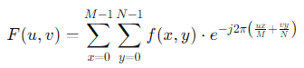

Here, F(u,v) is the Fourier-transformed image, and f(x,y) is the original image in the spatial domain.

#### 2. Shift the Zero-Frequency Component

* **Center the Frequency Spectrum:** Shift the zero-frequency component to the center of the spectrum using the fftshift function. This makes it easier to apply filters.

#### 3. Create the Gaussian High-Pass Filter

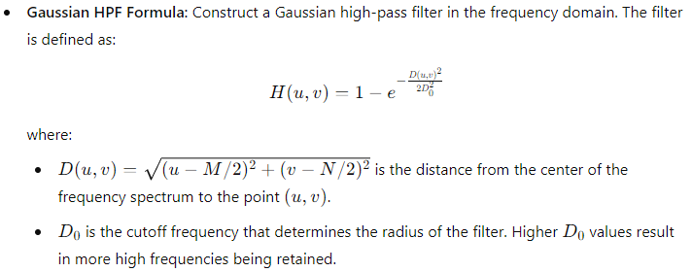

#### 4. Apply the Filter in the Frequency Domain

* **Element-wise Multiplication:** Multiply the frequency-domain image F(u,v) by the Gaussian HPF H(u,v):

*G(u,v) = H(u,v) × F(u,v)*

This operation enhances the high-frequency components while attenuating the low-frequency components.

#### 5. Convert the Image Back to the Spatial Domain

* **Inverse Fourier Transform:** Apply the Inverse Fourier Transform (IDFT) to convert the filtered image back to the spatial domain:

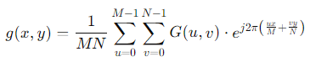

* **Magnitude Computation:** Take the magnitude of the complex result to obtain the real image.

#### 6. Post-processing

* **Remove Artifacts:** Sometimes, the resulting image might have some artifacts due to processing. These can be removed using simple image processing techniques like contrast adjustment or clipping the pixel values.
* **Normalization:** Normalize the pixel values to the appropriate range (e.g., [0, 255] for 8-bit images).

### Summary

* **Goal:** The Gaussian High-Pass Filter in the frequency domain is used to enhance the sharpness of an image by preserving high-frequency components and attenuating low-frequency ones.
* **Process:** The image is transformed into the frequency domain using FFT, a Gaussian HPF is applied, and the result is transformed back into the spatial domain using inverse FFT.
* **Implementation Consideration:** Careful choice of the cutoff frequency D0 is important to ensure that the desired amount of high-frequency information is retained, and low-frequency noise is effectively suppressed.

This process enhances the edges and fine details in an image, making it appear sharper.

**Explain how Hough transform is useful in line detection?**

### Hough Transform for Line Detection

The Hough Transform is a powerful technique used in image processing for detecting geometric shapes, particularly lines, within an image. The method is especially effective in cases where the shapes are partially obscured or noisy, making it robust for detecting lines in complex images.

### Concept Behind the Hough Transform

In its simplest form, the Hough Transform is used to detect straight lines in an image. The idea is to transform the problem of finding lines in the spatial domain (image space) into a problem of finding points in a different parameter space (Hough space).

#### 1. Representation of a Line

A straight line in the image space can be represented by the equation:

y = mx + cy

However, this form becomes impractical for vertical lines (where mmm becomes infinite). Therefore, the Hough Transform uses the following parametric form:

ρ = xcosθ + ysinθ

Here:

* ρ is the perpendicular distance from the origin to the line.
* θ is the angle between the perpendicular line and the x-axis.

This equation represents the line in terms of the parameters ρ and θ. Each line in the image space corresponds to a point in the ρ-θ space (Hough space).

#### 2. Mapping Points to the Hough Space

For each pixel (x, y) in the image that is part of an edge (typically found using an edge detection algorithm like Canny), you calculate a set of possible lines that could pass through that point. Each line corresponds to a pair (ρ, θ) in the Hough space.

* For a fixed point (x, y), vary θ from 0∘ to 180∘ (or 0 to π radians), and compute the corresponding ρ.
* Plot these (ρ, θ) pairs in the Hough space. This will trace out a sinusoidal curve.

#### 3. Accumulator Array

* **Accumulator Array:** The Hough space is typically represented as an accumulator array, where each cell in the array corresponds to a specific (ρ, θ) pair. As the algorithm processes each edge pixel in the image, it "votes" in the accumulator array for all possible lines that pass through that pixel.
* **Peaks in the Accumulator Array:** After all edge points have been processed, the accumulator array will have peaks (local maxima) where many sinusoidal curves intersect. Each peak corresponds to a line in the image space, with the coordinates of the peak (ρ, θ) defining the line.

#### 4. Line Detection

* **Identifying Lines:** The peaks in the accumulator array are identified, and each peak corresponds to a detected line in the original image. The parameters ρ and θ are used to reconstruct the line in the image space.
* **Filtering Peaks:** To avoid detecting spurious lines, a threshold is often applied to the accumulator array to consider only those peaks that have a significant number of votes, corresponding to prominent lines in the image.

### Example of Line Detection Using Hough Transform

1. **Edge Detection:** Apply an edge detection algorithm (e.g., Canny) to an image to obtain a binary image where edge pixels are marked.
2. **Hough Transform:** Use the Hough Transform to map the edge pixels to the Hough space and fill the accumulator array.
3. **Peak Detection:** Identify the peaks in the accumulator array that correspond to lines in the image.
4. **Draw Lines:** Reconstruct the detected lines in the image space using the ρ and θ values from the accumulator array.

### Advantages of Hough Transform

* **Robust to Noise:** The Hough Transform can detect lines even when they are partially obscured or corrupted by noise.
* **Flexible:** The technique can be extended to detect other shapes, such as circles, ellipses, or arbitrary curves, by modifying the parameterization.

### Problems and Limitations

1. **Computational Complexity:** The algorithm can be computationally expensive, especially for high-resolution images or when detecting complex shapes.
2. **Resolution of Accumulator Array:** The accuracy of detected lines depends on the resolution of the accumulator array. A coarse resolution may miss lines, while a fine resolution increases computational load.
3. **Sensitive to Thresholds:** The detection of lines is sensitive to the threshold applied to the accumulator array, which needs to be carefully chosen to avoid false positives or missed lines.
4. **Detection of Parallel Lines:** Closely spaced parallel lines can result in overlapping peaks in the Hough space, making it difficult to distinguish between them.

### Summary

The Hough Transform is a robust technique for detecting lines in images, particularly when lines are partially hidden or in noisy environments. By mapping edge points to a parameter space, the method transforms the complex problem of line detection into a simpler problem of finding peaks in the Hough space. Despite its computational demands and sensitivity to parameter choices, it remains a fundamental tool in image analysis and computer vision.

**Explain the Bit plane slicing technique for image enhancement.**

### Bit Plane Slicing Technique for Image Enhancement

**Bit Plane Slicing** is an image processing technique used to analyze and enhance different bit planes of an image. It allows us to visualize and manipulate the contributions of individual bits in the pixel values of an image, which can be useful for various image enhancement and analysis tasks.

### Concept of Bit Plane Slicing

1. **Pixel Representation:**
   * **Gray-Level Images:** In a grayscale image, each pixel's intensity value is typically represented using an 8-bit value (for 256 gray levels), which means each pixel can be expressed in binary as an 8-bit number.
   * **Bit Planes:** Each of the 8 bits in the binary representation of a pixel is referred to as a bit plane. The 8-bit value is composed of a most significant bit (MSB) and 7 less significant bits (LSB).
2. **Bit Plane Extraction:**
   * **Individual Planes:** Bit plane slicing involves extracting and analyzing each of these 8 planes separately. Each bit plane represents a binary image where the pixels have values of either 0 or 1 depending on whether the corresponding bit is set (1) or not set (0).

### Steps in Bit Plane Slicing

1. **Convert to Binary Representation:**
   * Convert the grayscale image pixel values into their binary form. For an 8-bit image, each pixel is represented by an 8-bit binary number.
2. **Extract Bit Planes:**
   * **Bit Plane Extraction:** For each bit plane (from the least significant bit to the most significant bit), create a binary image where each pixel value corresponds to the value of the specific bit. For example:
     + **Least Significant Bit (LSB):** Represents the least significant 1 bit of the pixel value.
     + **Most Significant Bit (MSB):** Represents the most significant 8th bit of the pixel value.
   * **Binary Image:** A bit plane will have pixel values of either 0 or 255, where 255 corresponds to the bit being set (1), and 0 corresponds to the bit being unset (0).
3. **Enhance Image:**
   * **Visualize Contributions:** Each bit plane can be analyzed and visualized to understand the contribution of different bits to the overall image. Enhancing specific bit planes can highlight certain features of the image.
   * **Combination:** By combining specific bit planes, you can enhance or reconstruct images. For instance, combining higher bit planes might retain the most important features of an image, while lower bit planes can add detail or noise.

### Applications of Bit Plane Slicing

1. **Image Enhancement:**
   * **Highlight Details:** By manipulating or enhancing specific bit planes, you can emphasize certain features of an image. For instance, high bit planes (e.g., the 7th and 8th) often contain more significant details, while lower bit planes might capture finer details or noise.
2. **Image Compression:**
   * **Bit Plane Analysis:** Analyzing bit planes can help in image compression techniques, where less significant bit planes may be discarded to reduce the image size without significantly affecting perceived quality.
3. **Feature Extraction:**
   * **Texture and Patterns:** Bit plane slicing can be used to extract texture or pattern information from an image. For example, certain patterns or structures might be more prominent in specific bit planes.
4. **Image Analysis:**
   * **Binary Representation:** It allows for a deeper analysis of how different bits contribute to the image, which can be useful in various image processing applications.

### Example of Bit Plane Slicing

1. **Original Image:**
   * Convert the image to its binary representation.
2. **Extract Bit Planes:**
   * Extract each bit plane from the binary representation.
3. **Enhance or Analyze:**
   * Visualize or enhance specific bit planes to highlight features or perform further analysis.
4. **Combine Planes:**
   * Combine selected bit planes to reconstruct or enhance the image.

### Summary

**Bit Plane Slicing** is a technique for image enhancement and analysis by isolating and manipulating individual bits of pixel values. It provides a way to understand and enhance different levels of detail in an image. By analyzing and processing different bit planes, one can highlight specific features, compress images, or extract useful information for various applications.

**Find the Inverse DFT (IDFT) of given function using DIT-IFFT f(x) = {10, -2+2j, -2, -2-2j}.**

To find the Inverse Discrete Fourier Transform (IDFT) using the Decimation-In-Time (DIT) Inverse Fast Fourier Transform (IFFT), follow these steps:

### Given:

f(x) = {10, −2+2j, −2, −2−2j}

This sequence represents the frequency domain coefficients, and we need to compute their inverse transform to obtain the time-domain sequence.

### Steps for Inverse DFT using DIT-IFFT:

#### 1. **Rearrange Coefficients:**

* Ensure the sequence f(x) is in the correct order for DIT-IFFT. Here, f(x) is already given in the frequency domain.

#### 2. **Compute the IDFT:**

The IDFT formula is:

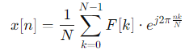

where F[k] are the frequency domain coefficients, N is the total number of points (4 in this case), and n ranges from 0 to N−1.

For N = 4, we have:



Let’s compute the IDFT for each nnn from 0 to 3.

#### 3. **Perform the Calculations:**

For n = 0:

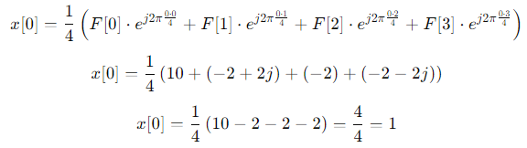

For n = 1:

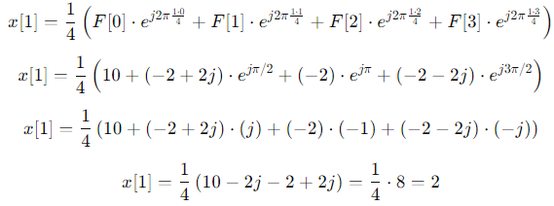

For n = 2:

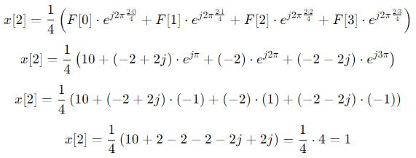

For n = 3:

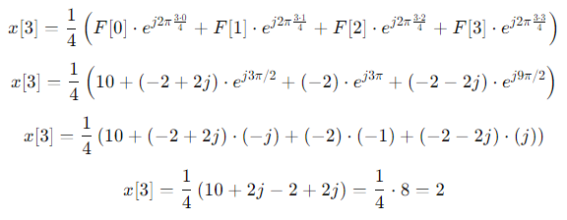

**Results:**

The IDFT of the sequence {10, −2+2j, −2, −2−2j} is: x = {1, 2, 1, 2}.

**Find DFT of given function using DIT-FFT. F(x) = {1, 2, 3, 4}.**

To find the Discrete Fourier Transform (DFT) of the sequence F(x) = {1, 2, 3, 4} using the Decimation-In-Time (DIT) Fast Fourier Transform (FFT) algorithm, follow these steps:

### Given Sequence:

x = {1, 2, 3, 4}

### Steps to Compute DFT using DIT-FFT

1. **Decompose the Sequence:** The sequence F(x) has 4 elements. Since 4 is a power of 2 (i.e., 22), we can apply the radix-2 DIT-FFT algorithm.
2. **Bit-Reversal Permutation:** For a sequence of length N = 4, we need to perform bit-reversal permutation. The indices are reversed based on their binary representation.
   * Original indices: 0, 1, 2, 3
   * Binary representation: 00, 01, 10, 11
   * Bit-reversed indices: 00, 10, 01, 11
   * Reordered sequence: F(0) = {1, 3, 2, 4}
3. **Compute the FFT in Stages:**
   * **Stage 1:** Compute the 2-point FFT for the reordered sequence.

Split the sequence into two parts:

* + - X0 = {1, 2}
    - X1 = {3, 4}

Compute the 2-point DFT for each part:

For X0:

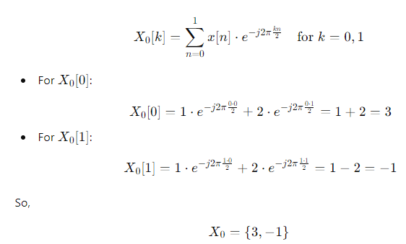

Similarly, for X1​:

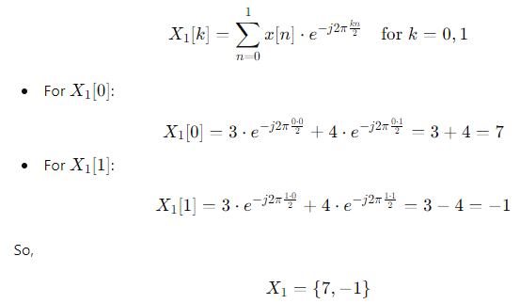

* + **Stage 2:** Combine the results from the previous stage using the FFT butterfly operation.

Use formula:

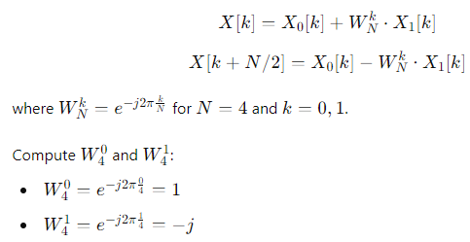

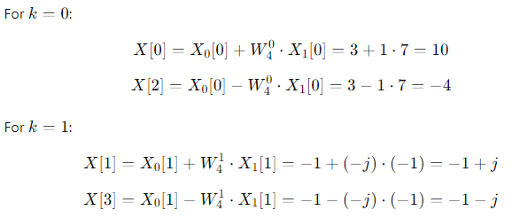

### Results

The DFT of the sequence {1, 2, 3, 4} is: X = {10, −1+j, −4, −1−j}.

This is the frequency domain representation of the given sequence using the DIT-FFT algorithm.